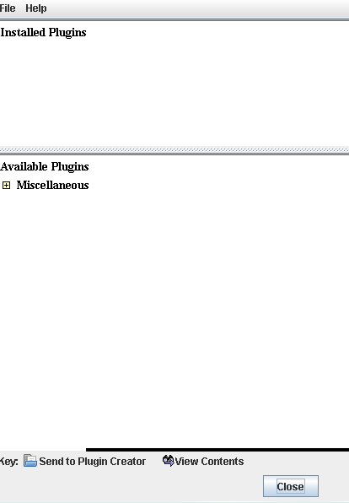

Why I can’t find Plugin Manager as shown in “help” menu?
Plugin Manager as shown in “help” menu show several option,
not blank like my Plugin Manager.
This is the picture Plugin Manager as shown in “help” menu:

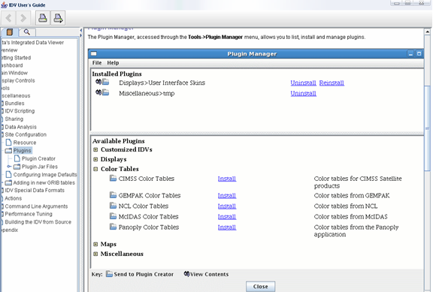

So which plugin I must install? If plugin as you suggested refers to
file ‘plugin.jar’ in directory C:\Program Files\IDV_2.5\jre\lib\plugin.jar, then why
when I try to install ‘plugin.jar’ appear some error massage as shown in picture below:

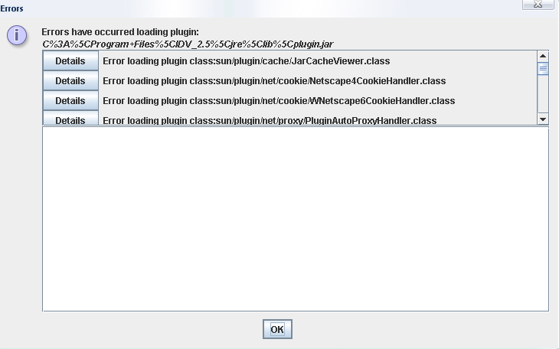

And still, after I install “plugin.jar” my Plugin Manager show blank window, this is the picture:
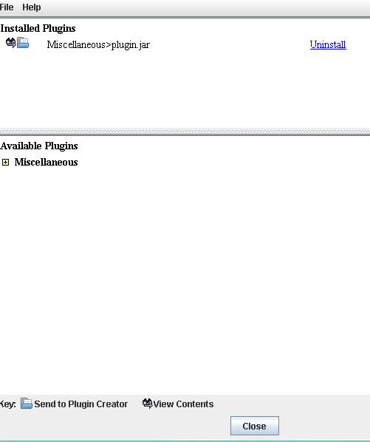

So my question is which one plugin file I must install? And where I can found it?
If I must download ‘plugin’ file, please send me link to download that.

Please help me, I just want to displaying focal mechanism. Simply, I just want to find Point Data Symbol “Focal Mechanism, lower half sphere” and “Focal mechanism, full sphere”.

Thank’s for your attention.

