Open GeoSpatial Consortium Inc.
Date: 2010-04-01
Reference number of this OpenGIS© Project Document: OGC 10-NCD
Version: 0.0.1
Category: OpenGIS© Encoding Standard
Editor: Ben Domenico
NetCDF Core

To obtain additional rights of use, visit http://www.opengeospatial.org/legal/.

Warning
This document is not an OGC Standard. It is distributed for review and comment. It is subject to change without notice and may not be referred to as an OGC Standard.
Recipients of this document are invited to submit, with their comments, notification of any relevant patent rights of which they are aware and to provide supporting documentation.

Document type: OpenGIS© Encoding Standard
Document subtype:
Document stage: Draft
Document language: English
Table of Contents
1 Scope 4
2 Compliance 4
3 Normative references 4
4 Terms and definitions 4
4.1 NetCDF 5
4.2 Attribute 5
4.3 Variable 5
4.4 Dimension 5
5 Document Conventions 5
5.1 UML notation 5
5.2 Data dictionary tables 5
5.3 Namespace prefix conventions 5
5.4 XPath notation 6
6 NetCDF classic data model 6
6.1 NetCDF classic model overview 6
6.2 NetCDF classic data model UML notation 7
6.3 NetCDF classic data model requirements 7
6.3.1 NetCDF classic information representation 7
6.3.2 Primitive data types 7
6.3.3 Variables 8
6.3.4 Dimensions 8
6.3.5 Attributes 8
[1] OGC 07-067r5, Web Coverage Service Implementation Standard, version 1.1.2 Error! Bookmark not defined.
[2] OGC 07-068r4, Web Coverage Service (WCS) – Transaction operation extension, version 1.1.4 Error! Bookmark not defined.
[3] OGC 08-059r3, Web Coverage Service (WCS) – Processing extension, version 1.0.0 Error! Bookmark not defined.
Annex A (normative) Abstract test suite 9
A.1 Conformance Test Class: netCDF Core 9
A.1.1 Req 1 9
A.1.2 Req 2 10
A.1.3 Req 3 10
A.1.4 Req 4 10
A.1.5 Req 5 10
A.1.6 Req 6 11
A.1.7 Req 7 11
A.1.8 Req 8 11
A.1.9 Req 9 11
A.1.10 Req 10 11
A.1.11 Req 11 12
A.1.12 Req 12 12

Tables Page
Table 1 — Namespace mappings 6

Figure 1: netCDF classic data model 7

- Preface
This document specifies the core of an OGC NetCDF encoding standard.

Suggested additions, changes, and comments on this draft report are welcome and encouraged. Such suggestions may be submitted by email message or by making suggested changes in an edited copy of this document.

- Terms and definitions
This document uses the specification terms defined in Subclause 5.3 of [OGC 06-121r8], which is based on the ISO/IEC Directives, Part 2, Rules for the structure and drafting of International Standards. In particular, the word “shall” (not “must”) is the verb form used to indicate a requirement to be strictly followed to conform to this standard.
- Submitting organizations
The following organizations have submitted this Implementation Specification to the Open GeoSpatial Consortium, Inc.:

- The University Corporation for Atmospheric Research

- Document Contributor Contact Points
Name | Organization
Ben Domenico | UCAR Unidata
Stefano Nativi | University of Florence, CNR/IMAA

- Revision history
Date | Release | Author | Paragraph modified | Description
2010-03-31 | 2.0.0 | Ben Domenico,  Stefano Nativi | All | Created
- Changes to the OpenGIS® Abstract Specification
The OpenGIS® Abstract Specification does not require any changes to accommodate the technical contents of this (part of this) document.
- Future Work
Based on this NetCDF core standard, several extensions are foreseen.
Foreword
Some of the elements of this document may be the subject of patent rights. Open GeoSpatial Consortium Inc. shall not be held responsible for identifying any such patent rights.
Attention is drawn to the possibility that some of the elements of this document may be the subject of patent rights. The Open Geospatial Consortium Inc. shall not be held responsible for identifying any or all such patent rights.
Recipients of this document are requested to submit, with their comments, notification of any relevant patent claims or other intellectual property rights of which they may be aware that might be infringed by any implementation of the standard set forth in this document, and to provide supporting documentation.

Introduction
The OGC NetCDF encoding supports electronic encoding of geospatial data, that is, digital geospatial information representing space-varying phenomena.
This document specifies the netCDF core; every netCDF encoding shall adhere to this specification.
NetCDF (network Common Data Form) is a data model for array-oriented scientific data, a freely distributed collection of access libraries implementing support for that data model, and a machine-independent format. Together, the interfaces, libraries, and format support the creation, access, and sharing of scientific data.
NetCDF data is intended to make possible the creation of collections of data that are:
- Self-Describing: NetCDF datasets include information about the data they contain.
- Portable: Computers with different ways of storing integers, characters, and floating pointnumbers can access netCDF data.
- Direct-access: A small subset of a large data set may be accessed efficiently, without first reading through all the preceding data.
- Appendable: Data may be appended to a properly structured netCDF file without copying the data set or redefining its structure.
- Sharable: One writer and multiple readers may simultaneously access the same netCDF file. Using parallel netCDF interfaces, multiple writers may write a file concurrently.
- Archivable: Access to current and earlier forms of netCDF data will be supported by current and future versions of the software.
The purpose of netCDF is to provide a data model, software libraries, and machine-independent data format for geoscience data. Together, the netCDF interfaces, libraries, and format support the creation, access, and sharing of scientific data. With suitable community conventions, netCDF can help improve interoperability among data providers, data users, and data services.
NetCDF Core

Scope
This document specifies how data are encoded in netCDF. It does so by specifying a core set of requirements which every netCDF encoding must adhere to. NetCDF extensions can add further functionality to the core requirements. Actually, this core is not complete in the sense that it specifies the netCDF data model which allows implementation of an encoding, but requires netCDF extension specifications for specific encodings. This document indicates which extensions, at minimum, need to be considered in addition to this core to form a complete netCDF implementation.

Compliance
Annex A (normative) specifies compliance tests which shall be tested by any service claiming to implement an OGC netCDF encoding.

Normative references
The following normative documents contain provisions that, through reference in this text, constitute provisions of this specification. For dated references, subsequent amendments to, or revisions of, any of these publications do not apply. For undated references, the latest edition of the normative document referred to applies.
IETF RFC 2387, The MIME Multipart/Related Content-type. IETF, 1998
IETF RFC 2396, Uniform Resource Identifiers (URI): Generic Syntax. IETF, 1998
NASA ESDS-RFC-011v2.00 R. Rew, E. Hartnett, D. Heimbigner, E. Davis, J. Caron: NetCDF Classic and 64-bit Offset File Formats
http://www.esdswg.org/spg/rfc/esds-rfc-011/ESDS-RFC-011v2.00.pdf
Unidata UCAR, NetCDF Reference Document, 2009
http://www.unidata.ucar.edu/software/netcdf/docs/
Unidata UCAR, NetCDF User Guide
http://www.unidata.ucar.edu/software/netcdf/docs/netcdf.html
Unidata UCAR, NetCDF Reference Implementations
ftp://ftp.unidata.ucar.edu/pub/netcdf/netcdf.tar.gz

Terms and definitions
For the purposes of this document, the terms and definitions given in the above references apply. In addition, the following terms and definitions apply.

NetCDF
NetCDF (network Common Data Form) is a data model for array-oriented scientific data, a freely distributed collection of access libraries implementing support for that data model, and a machine-independent format. Together, the interfaces, libraries, and format support the creation, access, and sharing of scientific data.
The classic model represents information in a netCDF data set using dimensions, variables, and attributes, to capture the meaning of array-oriented scientific data.

Attribute
Attributes hold metadata (data about data). An attribute contains information about properties of a variable or an entire data set.

Variable
Variables hold data values. In the classic model, a variable can hold a multidimensional array of values of the same type.

Dimension
Dimensions are used to specify variable shapes, common grids, and coordinate systems.

Document Conventions

UML notation
All the diagrams that appear in this specification are presented using the Unified Modeling Language (UML) static structure diagram, as described in Subclause 5.2 of OGC Web Services Common [OGC 06-121r8].

Data dictionary tables
The UML model data dictionary is specified herein in a series of tables. The contents of the columns in these tables are described in Subclause 5.5 of [OGC 06-121r8]. The contents of these data dictionary tables are normative, including any table footnotes.

Namespace prefix conventions
The following namespaces are used in this document. The prefix abbreviations used constitute conventions used here, but are not normative. The namespaces to which the prefixes refer are normative, however.

Prefix | Namespace URI | Description
gml | http://www.opengis.net/gml/3.2 | GML 3.2.1
wcs | http://www.opengis.net/wcs/2.0 | WCS 2.0
gmlwcs | http://www.opengis.net/wcs/2.0/gml | GML Application Schema for WCS 2.0
xsd | http://www.w3.org/2001/XMLSchema | XML Schema namespace
- — Namespace mappings

XPath notation
Traversal of complex entities and the contents of WCS responses are specified herein using XPath 2.0 [W3C 2007]. All XPath expressions refer to the XML Schema of GML and WCS.

NetCDF classic data model
This Clause specifies the underlying data model for a netCDF classic dataset used in the further Clauses of this standard.

NetCDF classic model overview
The classic model represents information in a netCDF data set using dimensions, variables, and attributes, to capture the meaning of array-oriented scientific data. Figure 1 presents a simplified UML diagram of the classic data model. Variables hold data values. In the classic model, a variable can hold a multidimensional array of values of the same type. A variable has a name, type, shape, attributes, and values. The shape of a variable is specified with a list of zero or more dimensions:
- 0 dimensions: a scalar variable with only one value
- 1 dimension: a 1-D (vector) variable
- 2 dimensions: a 2-D (matrix or grid) variable
- ...
Dimensions are used to specify variable shapes, common grids, and coordinate systems. A dimension has a name and a length. Dimensions may be shared among variables, indicating a common grid. Dimensions may be associated with coordinate variables to identify coordinate axes. In the classic model, at most one dimension can have the unlimited length, which means variables can grow along that dimension. Record dimension is another term for an unlimited dimension. (In the enhanced model, multiple dimensions can have the unlimited length.) Attributes hold metadata (data about data). An attribute contains information about properties of a variable or an entire data set. Variable attributes may be used to specify properties such as units. Attributes that apply to a whole data set, also called global attributes, may be used to record properties of all the data in a file, such as processing history or conventions used. An attribute may have zero, one, or multiple values (1-D), but attributes cannot be multidimensional.
NetCDF conventions are defined primarily in terms of attributes. Thus the names of attributes are typically standardized in conventions rather than the names of variables. NetCDF conventions are specified in extensions to this core specification.

NetCDF classic data model UML notation
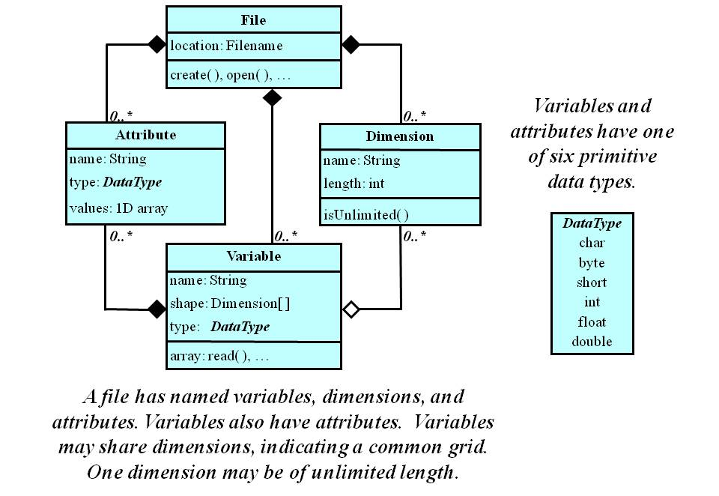
Figure 1: netCDF classic data model

For a more comprehensive explanation of the netCDF data model, see the NetCDF User's Guide[1] or the online NetCDF Workshop for Developers and Data Providers [3].

NetCDF classic data model requirements
The netCDF classic data model requirements specified in this section are verbal representations of the netCDF classic data model shown in the previous section

NetCDF classic information representation
Req 1 NetCDF classic datasets shall represent information using dimensions, variables and attributes using the primitive data types as shown in the UML diagram in Figure 1.

Primitive data types
Req 2 Variables and attributes shall have one of six primitive data types: char, byte, short, int, float, double.

Variables
Req 3 Variables shall contain data values
Req4 A variable shall have a name, type, shape, attributes, and values
Req5 The shape of a variable shall be specified with a list of zero or more dimensions

Dimensions
Req 6 Dimensions shall specify variable shapes, common grids, and coordinate systems.
Req 7 A dimension shall have a name and a length

Unlimited dimension
Req 8 At most one dimension (the record dimension) shall have unlimited length

Attributes
Req 9 Global attributes shall hold metadata about the entire dataset
Req 10 A variable attribute shall hold metadata about one variable
Req 11 An attribute shall have zero, one, or multiple values (one dimensional)
Req 12 An attribute shall have at most one dimension

Bibliography
IETF RFC 2387, The MIME Multipart/Related Content-type. IETF, 1998
IETF RFC 2396, Uniform Resource Identifiers (URI): Generic Syntax. IETF, 1998
NASA ESDS-RFC-011v2.00 R. Rew, E. Hartnett, D. Heimbigner, E. Davis, J. Caron: NetCDF Classic and 64-bit Offset File Formats
CF-netCDF Overview [OGC 10-NBP]
http://www.esdswg.org/spg/rfc/esds-rfc-011/ESDS-RFC-011v2.00.pdf
Unidata UCAR, NetCDF Reference Document, 2009
http://www.unidata.ucar.edu/software/netcdf/docs/
Unidata UCAR, NetCDF User Guide
http://www.unidata.ucar.edu/software/netcdf/docs/netcdf.html
Unidata UCAR, NetCDF Reference Implementations
ftp://ftp.unidata.ucar.edu/pub/netcdf/netcdf.tar.gz

Annex A
(normative)
Abstract test suite
A netCDF endcoding must satisfy the following characteristics to be conformant with this specification. Note, however, that an encoding extension is needed in order to actually implement executable tests corresponding to these abstract tests.
  - Conformance Test Class: netCDF Core
    - Error: Reference source not found
Test statement | NetCDF classic datasets shall represent information using dimensions, variables and attributes using the primitive data types as shown in the UML diagram in Figure 1.
Test approach | Open the dataset and check that the result is valid.
    - Error: Reference source not found
Test statement | Variables and attributes shall have one of six primitive data types: char, byte, short, int, float, double.
Test approach | Open the dataset and check that all variables and attributes have one of six primitive data types: char, byte, short, int, float, double.
.
    - Error: Reference source not found
Test statement | Variables shall contain data values.
Test approach | Open the dataset and check that all variables contain data values.

    - Error: Reference source not found
Test statement | A variable shall have a name, type, shape, attributes, and values.
Test approach | Open the dataset and check that all variables have a name, type, shape, attributes, and values.
.
    - Error: Reference source not found
Test statement | The shape of a variable shall be specified with a list of zero or more dimensions
Test approach | Open the dataset and check that the shape of all variables is with a list of zero or more dimensions.
    - Error: Reference source not found
Test statement | Dimensions shall specify variable shapes, common grids, and coordinate systems
Test approach | Open the dataset and check that all dimensions specify variable shapes, common grids, and coordinate systems.
    - Error: Reference source not found
Test statement | Dimensions shall specify variable shapes, common grids, and coordinate systems
Test approach | Open the dataset and check that all dimensions specify variable shapes, common grids, and coordinate systems.
    - Error: Reference source not found
Test statement | At most one dimension (the record dimension) shall have unlimited length
Test approach | Open the dataset and check that at most one dimension (the record dimension) shall have unlimited length.

    - Error: Reference source not found
Test statement | Global attributes shall hold metadata about the entire dataset
Test approach | Open the dataset and check that global attributes hold metadata about the entire dataset.
    - Error: Reference source not found
Test statement | A variable attribute shall hold metadata about one variable
Test approach | Open the dataset and check that variable attribute holds metadata about one variable
    - Error: Reference source not found
Test statement | An attribute shall have zero, one, or multiple values (one dimensional).
Test approach | Open the dataset and check that each attribute has one, or multiple values (one dimensional).
    - Error: Reference source not found
Test statement | An attribute shall have at most one dimension.
Test approach | Open the dataset and check that each attribute has at most one dimension.

-- end of ATS --

