WCS Extension Standard for CF-netCDF Coverage Encoding 1.0XXX
TITLE:

AUTHORS: Ben Domenico, UCAR/Unidata
ben@unidata.ucar.edu
Stefano Nativi, CNR/IMAA
nativi@imaa.cnr.it

DATE: March 2008

CATEGORY: Draft Proposal

This is a draft document. Editorial comments, unresolved issues, etc, are noted with italics and/or highlighting. Send comments to the authors listed above.

BACKGROUND
This document provides an application profile to enable WCS 1.x clients and servers to support coverages encoded in netCDF that conforms to the Climate and Forecast (CF) conventions (CF-netCDF). This document is specific to coverage formats encoded in netCDF 3 using CF 1.1.
The perceived need for a WCS 1.1. application profile for CF-netCDF arose from the experiences of the OGC GALEON Interoperability Experiment. In this experiment, several WCS clients were successful in accessing data from WCS servers which encoded the data in CF (Climate and Forecast conventions, version 1.0) compliant netCDF (version 3.0) form. NetCDF (network Common Data Form) is a widely-used set of interfaces for array-oriented data access and a freely-distributed collection of data access libraries for C, Fortran, C++, Java, and other languages. The netCDF libraries support a machine-independent, self-documenting binary format for representing scientific data. Together, the interfaces, libraries, and format support the creation, access, and sharing of scientific data. The CF conventions define metadata (internal to a netCDF file) that provide a definitive description of what the data in each variable represents, and of the spatial and temporal properties of the data.. This enables the users of data from different sources to decide which quantities are comparable and how they relate to one another in space and time.
The GALEON experiment has proven that the CF-netCDF encoding format would be a viable and valuable WCS encoding format. However, CF-netCDF is not among the list of 5 “required supported formats” in the WCS 1.0 specification.
Based on the GALEON experiment and subsequent discussion in the WCS Revision Working Group , this proposal in conjunction with the WCS 1.1 specification will establish CF-netCDF as a WCS “supported encoding format.” without making the encoding format completely arbitrary.

OUTLINE
According to Section 9.3.2.2 of WCS 1.1 (07-067r2):
These encoding profiles shall contain the following information:
a) MIME type(s) and brief description: a concise overview of the encoding format, including the MIME type string(s) used to refer to it, the files required (e.g. header, dictionary, georeferencing, etc.), and the “role” values in the Xlink references in the GetCoverage response (see Subclauses 10.3.11.2 and I.3.2).
b) Pointers to documentation for the encoding format. This documentation shall clarify how the encoding convention represents locations, times, and physical quantities represented in the dataset.
c) Data model mapping to the Coverage Abstract Specification. This should include conventions for representing the spatio-temporal domain, and for representing the dimensions in the range. It should also describe limitations of the format for encoding complex coverages, and limitations of the coverage model for representing complex data structures encoded in the format.
d) Examples: A set of examples of the encoding format, and of corresponding Coverages XML response documents (see Subclauses 10.3.11.2 and I.3).
e) Pointers to implementing software for the encoding format. Providers of this software may license it in source code or executable form.
f) Compliance Testing: Pointers to mechanisms for testing whether resulting WCS coverages conform to the encoding format.
Note that the title for these encoding profiles has subsequently changed from “Application Profile” to “Extension Standard” which is the usage in this document which is mainly organizes according to the outline given above.

Overview of CF-netCDF for WCS
In brief, NetCDF is a an application programming interface as well as a self-documenting file format. The CF conventions specify the form of internal metadata describing the contents of a netCDF file.

NetCDF
NetCDF (network Common Data Form) is an interface for array-oriented data access and a library that provides an implementation of the interface. The netCDF library also defines a machine-independent format for representing scientific data. Together, the interface, library, and format support the creation, access, and sharing of scientific data.
The netCDF software includes C, Fortran 77, Fortran 90, and C++ interfaces for accessing netCDF data. These libraries are available for many common computing platforms.

CF Conventions
The CF conventions define metadata that provide a definitive description of what the data in each variable represents, and of the spatial and temporal properties of the data. This enables users of data from different sources to decide which quantities are comparable, and facilitates building applications with powerful extraction, regridding, and display capabilities.

Summary of Changes
This application profile makes the following sets of changes to WCS:
- A new MIME type is added: application/x-netcdf.
- GetCoverage has two main cases (described in more detail in Section 11 below):
- a complete GetCoverage response is transferred to the client;
- a partial GetCoverage response is transferred to the client.

DOCUMENTATION
This section provides pointers to documentation for netCDF and for the CF conventions. It contains explicit pointers to the key elements of the documentation that describe how the physical quantities represented in the dataset are named, how the location and time in space is specified -- the "what, where, when" of the datasets.

NetCDF
The netCDF home page is located at Unidata:
http://www.unidata.ucar.edu/software/netcdf/
A list of netCDF documents is available at:
http://www.unidata.ucar.edu/software/netcdf/docs/
There is a netCDF Users Guide at:
http://www.unidata.ucar.edu/software/netcdf/docs/netcdf.html

CF Conventions
The CF Conventions home page is located at PCMDI:
http://cf-pcmdi.llnl.gov/

Standard names
What do the numbers in a netCDF dataset represent? e.g., temperature, pressure, wind speed, salinity, radiance, reflectivity
- Description of CF standard names conventions:
http://cf-pcmdi.llnl.gov/documents/cf-conventions/1.1/ch03s03.html
- Table of CF Standard names:
http://cf-pcmdi.llnl.gov/documents/cf-standard-names/7/cf-standard-name-table.html

Units
What are the units of measure for the numbers in a netCDF dataset?
- Description of CF units of measure:
http://cf-pcmdi.llnl.gov/documents/cf-conventions/1.1/ch03.html#units

Coordinates
Where in space do the numbers represent measurements or modeled values?

Coordinate types
- Coordinate types description:
http://cf-pcmdi.llnl.gov/documents/cf-conventions/1.1/ch04.html

Coordinate systems
- Coordinate systems description:
http://cf-pcmdi.llnl.gov/documents/cf-conventions/1.1/ch05.html

Grid mappings
- Grid mappings description:
http://cf-pcmdi.llnl.gov/documents/cf-conventions/1.1/ch05s06.html

Time coordinate
When were the measurements taken or modeled values forecast?
- Time coordinate description:
http://cf-pcmdi.llnl.gov/documents/cf-conventions/1.1/ch04s04.html

Code for Implementing netCDF Interface
The vast majority of netCDF users use the same set of supported netCDF libraries to implement their systems. Consequently anyone intending to access data in netCDF form via the WCS interface should consider using this code which can be downloaded at:
- http://www.unidata.ucar.edu/software/netcdf/

Support
Potential users of netCDF may be interested in what support is available for the code and interface. Pointers to netCDF FAQ, mailing lists, documentation are available at:
- http://www.unidata.ucar.edu/software/netcdf/

CF-netCDF and Coverage (ISO 19123) Data Model Mapping
For use in the context of WCS, it is important to have an understanding of the mapping between the data models used for OGC coverages and those for the netCDF with CF conventions. The document describing this mapping has an conceptual overview section for background followed by a more formal and detailed section with UML diagrams comparing the two data models.
<<<Note that this is a pointer to a very old mapping document. But, at this point, I’m not sure which document we should point to. We are close to having the ESIN paper in press, but I don’t think it is officially there yet. Perhaps this should just wait until that paper is accepted. >>>
Data Model Mapping Related to Encoding of WCS Coverage in CF-netCDF
http://www.unidata.ucar.edu/projects/THREDDS/GALEON/CF-netCDFprofile/WCSnetCDFDataModelMapping.doc

Limitations
Many of the difficulties in serving CF netCDF data via WCS relate to the fact that, in effect, there are many coverages within one CF-compliant netCDF dataset:
- CF-netCDF datasets often include data for multiple parameters (e.g. temperature, pressure, wind speed, etc.). Sometimes these different fields have different domains which remains a problem in WCS 1.1
- CF-netCDF datasets that contain the output of numerical forecast models in effect have multple time dimensions (the time the model was run and the set of forecast times.) Here again, mechanisms for dealing with this are still limited in WCS 1.1.
- In general, many CF-netCDF datasets can be thought of as containing a set of coverages that correspond to multiple coverages (in the traditional sense of a 2D "layer"): multiple "parameters," multiple vertical layers, multiple times with non-traditional (in GIS terms) views (e.g., Hovmoller diagrams where longitude is the x-axis and time is the y-axis)
- In many netCDF files, the "height" dimension is represented by a non-spatical coordinate (e.g., pressure in the atmosphere or density in the oceans.) This is still not explicitly possible as a means for representing one of the domain dimensions in WCS 1.1. The main implication is that the bounding vertical limits in a bounding box cannot be expressed in the native elevation dimension in such cases for the netCDF. But a co-domain axis can be defined using the non-spatial dimension.
- An issue that arose during the GALEON I.E. is whether hould the WCS coverage concept be stretched to include non-gridded coverages such as:
  - collections of observational data taken at points (e.g., river or weather stations),
  - trajectories such as vertical profiles in the atmosphere or ocean,
  - time series of measurements at points or of "fields,"
or are these really more appropriately categorized as "features?" In terms of ISO 19123, these do fit the coverage model and the a coverage is of course a special instance of a general feature. However, such coverages are not part of the WCS 1.1 specifiation.
The bottom line is that WCS 1.1 supports only for regular and warped grids, hence only that subset of CF-neteCDF datasets can be served via the current specfication.
<<< John Evan’s comments on the earlier encoding profile draft are included below. I’ve tried to incorporate them where I understand them, but this warrants a closer look. >>>
Further notes on the data model mapping piece:
- The summary table on p.2 is very useful. Comments row by row:
1. I'm surprised to learn that CF-NetCDF disallows bitemporal grids (2 time dimensions)
2/3. WCS 1.1 no longer restricts the range to a single variable -- it can have multiple fields.
4. Not sure why axis order should matter. Just tag everything approriately and we're done?
6. NetCDF domain grids CAN be irregular; but WCS 1.1 provides only for regular and warped grids. If this is a subset of what NetCDF allows, then for WCS 1.1, let's restrict NetCDF grids to those that a WCS 1.1 (actually a GML CRS "Transformation") can describe.
Subsequent discussion raises a few additional issues:
p. 4 (top) At the end of the Row 1 discussion, I read that a NetCDF dataset can contain many coverages, which need not share a common spatio-temporal domain. This is outside the scope of an OGC coverage; so it would seem like a reasonable restriction when using NetCDF for WCS.
p. 4: The discussion of Row 2 discusses variables ("fields" in an OGC coverage) but says nothing about compound fields. Later on it clarifies that NetCDF variables are always scalar. Thus, using NetCDF for WCS would require one to either (a) disallow compound fields in WCS (to make the translation obvious); or (b) map WCS compound fields to multiple identically-defined NetCDF variables (necessitating redundant smentic metadata (a minor issue)).

NetCDF Examples
A set of representative examples of netCDF datasets is essential for gaining an understanding. A good place to start is:
- http://www.unidata.ucar.edu/software/netcdf/examples/files.html

Compliance Testing
It will be important to have some way to test whether a given client or server complies with the WCS specification when employing the CF-netCDF profile. In general, ensuring adherence to WCS is an issue separate from the CF-netCDF encoding. In order to test whether the netCDF encoded file transferred via a WCS getCoverage request complies with CF conventions, a CF conventions compliance test is available at:
- CF-netCDF Compliance:
http://badc.nerc.ac.uk/help/formats/netcdf/index_cf.html

CF-netCDF GetCoverage response
<<<< Ben has included this draft from Stefano inline, but I have not attempted to harmonize it with the rest of the document.>>>

Two main cases are possible:
1) a complete GetCoverage response is transferred to the client;
2) a partial GetCoverage response is transferred to the client.

Complete GetCoverage response
A complete GetCoverage response consists of a couple of sections:
i) Coverage Metadata -or equivalent information- (see Table 31)
ii) Grid Coverage(s) Values.

The Grid Coverage(s) Values are encoded and returned as one or more netCDF files: Grid Coverage File(s).

The Coverage metadata section is either encoded as a separate set of XML elements (i.e. forming a separate XML Coverage Metadata) or it is encoded in the Grid Coverage File(s), i.e. as CF elements. It is possible to find both forms of encodings; in that case there is a consistency issue.

Partial GetCoverage response

TBD

Complete GetCoverage response: the CF-netCDF case
These paragraph specifies how any of the coverage metadata (see Table 31) shall be included in the same file as the coverage grid values (i.e. CF-netCDF file). In fact the Coverage Metadata could be included in the netCDF Grid Coverage File encoded as KVP, according to the CF specification.

For each coverage, XML encoding should be used for the required coverage metadata specified in Subclause 10.3.9 (see Table 31), when not included in the same file as the coverage grid values.

WCS Complete GetCoverage response: Data structure
Figure 1 depicts the general Coverage Data structure, transferred by a WCS Complete GetCoverage response for the CF-netCDF application profile.

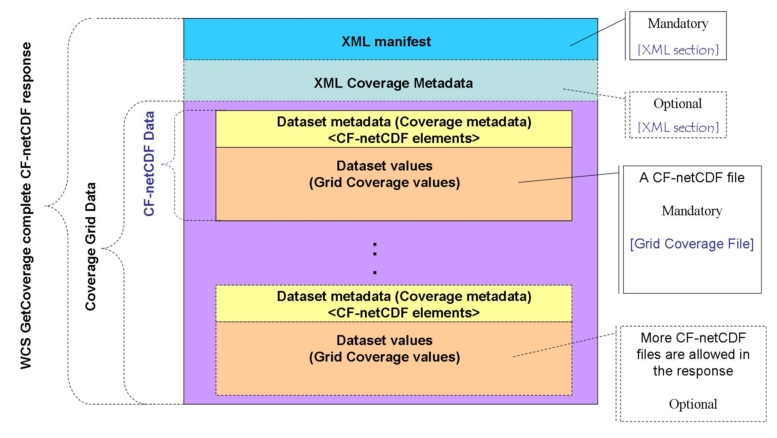
Fig. 1 – Data structure of a general WCS complete GetCoverage CF-netCDF response

The XML Coverage Metadata section of the WCS dataset is optional. In fact, it doesn’t exist if all the required metadata are encoded in the CF-netCDF data file.

If present, the XML Coverage Metadata section should use the XML encoding referenced in Sub-clause 10.3.9.

If the XML Coverage Metadata section is not present, then the CF-netCDF grid coverage file(s) must contain the analogous metadata elements. The structure of these metadata elements is described by the CF-netCDF encoding rules.

If metadata is present in both XML Coverage Metadata section and in the Grid Coverage files, then duplicate fields should be consistent. ( Note: This situation is strongly discouraged; nevertheless, it may be useful to encode the CF elements in XML in order to support rapid service chaining applications).

Since both XML Manifest and Coverage Grid Data are mandatory, then a WCS Complete GetCoverage response must be a multipart message.

WCS Complete GetCoverage response: Complex netCDF dataset structure
NetCDF community makes use of ncML to encode complex netCDF data structures. In fact it is possible to use ncML elements todefine a virtual netCDF dataset which consists of one or more netCDF data files.

In this case (i.e. ncML/CF-netCDF), the general Coverage Data structure is depicted in Figure2.

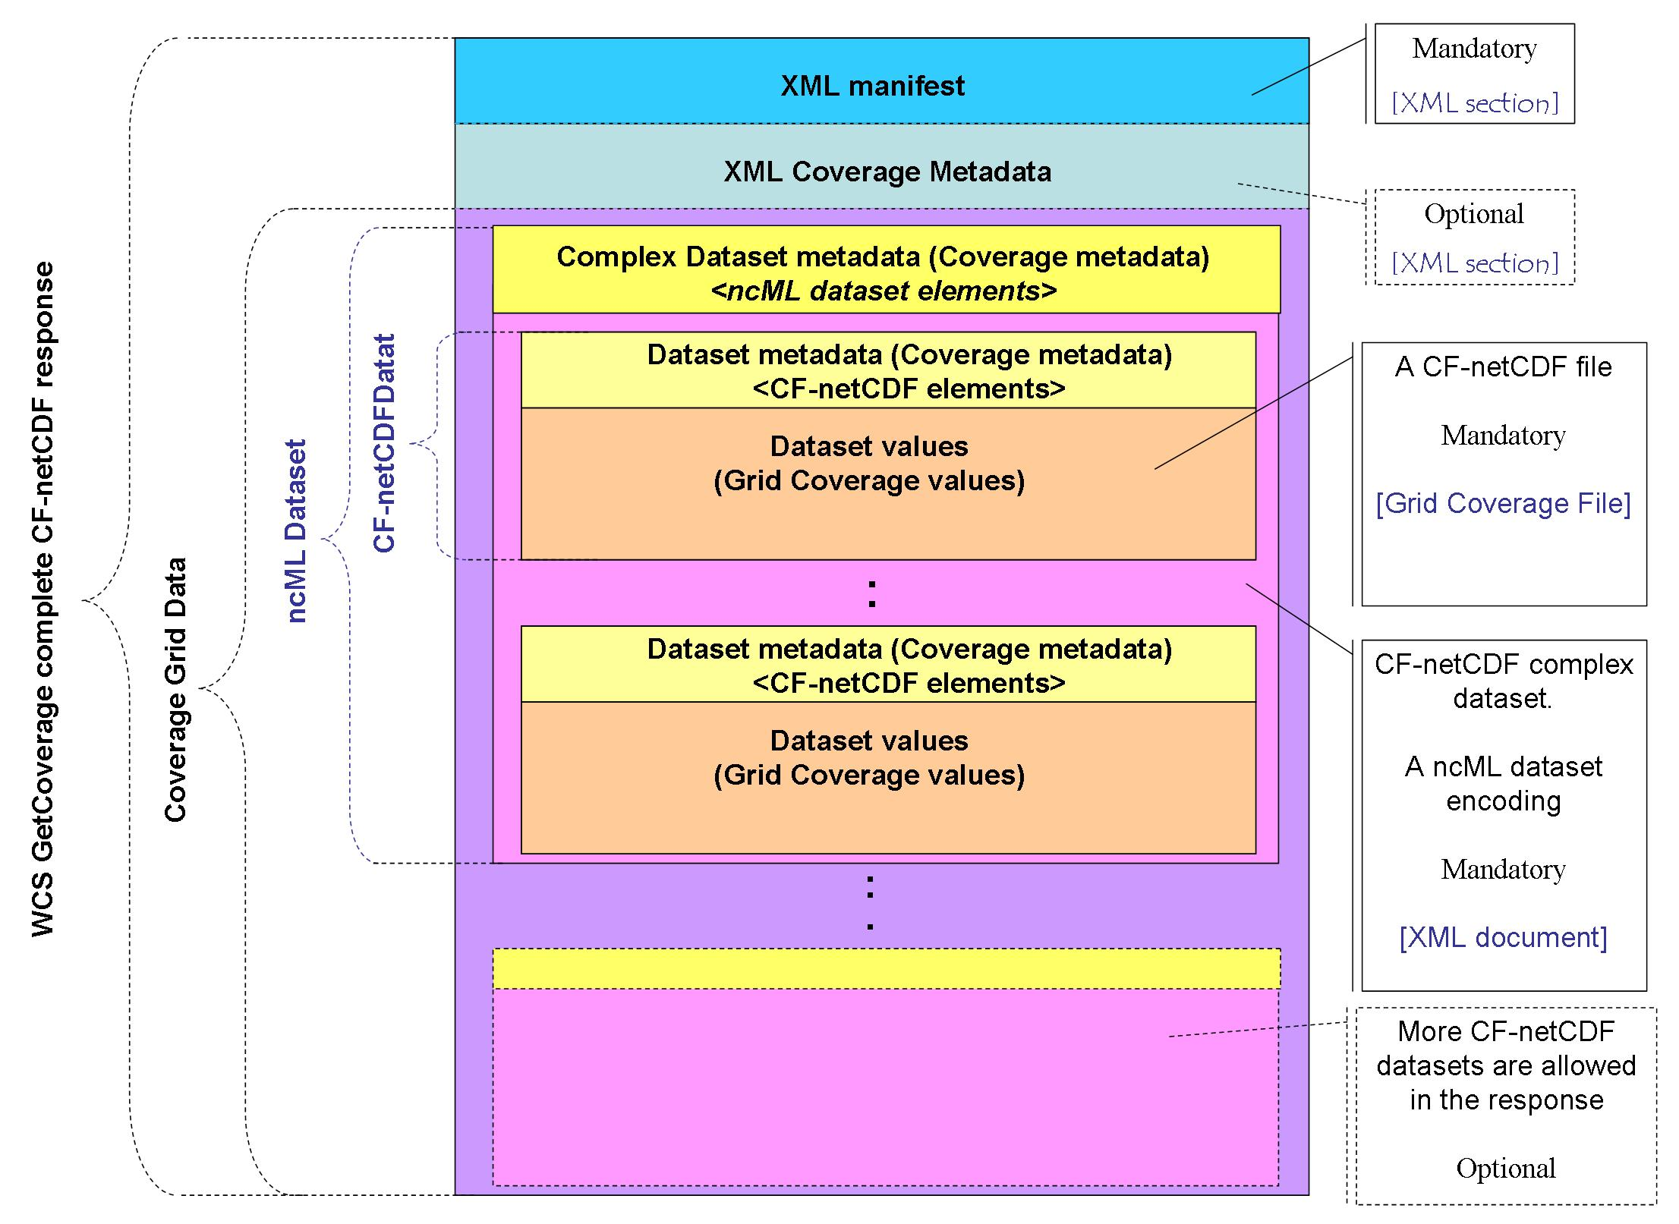
Fig. 2 – Data structure of a general WCS complete GetCoverage ncML/CF-netCDF response

It is noteworthy that there is a new data structure level: the ncML dataset which is described by its own metadata (i.e. ncML elements) in XML encoding and refers to one or more CF-netCDF datafiles.

WCS Complete GetCoverage response: Data encoding
MIME multipart response
GetCoverage responses transferred using MIME multipart shall be encoded according to [IETF RFC 2387], with the first part containing an XML encoded Coverages element. Every part of the multipart message shall have a content-id. The part containing the Coverages element shall have a content-id equal to “urn:ogc:wcs:1.1:coverages”; other parts may have any content-id values. The Coverages element shall reference other parts of the multipart message by their content-id values, prefixed by “cid:”.
EXAMPLE 1 If a multipart message contains a part with “content-id:ottawa_temp.tiff”, then the Coverage element would reference that part with the following XML fragment:
<Reference xlink:href="cid:ottawa_temp.tiff"/>
NOTE Using prefixes other than “cid:”, the Coverages element can (but normally should not) reference resources external to the MIME multipart message.

Example: Multipart-related

-a detailed example of a CF-netCDF GetCoverage response encoding based on the Miltipart-related technology. -

Example for CF-netCDF files

Example for a ncML dataset

References
- Proposed CF-netCDF WCS Encoding Profile
http://www.unidata.ucar.edu/projects/THREDDS/GALEON/netCDFprofile-short.htm
- List of URLs for netCDF and CF Conventions Documents
http://www.unidata.ucar.edu/projects/THREDDS/GALEON/netcdfAndCFwebpages.html
- Alternative forms for rendering netCDF metadata and data
http://www.unidata.ucar.edu/projects/THREDDS/GALEON/NetCDFandStandards.htm
- ISO/TC 211, ISO/PDTS 19103 Geographic information — Conceptual Schema Language, ISO/PDTS 19103:2003.
- ISO/TC 211, ISO/FDIS 19123 Geographic information — Schema for coverage geometry and functions, ISO/FDIS 19123:2005(E).
- UNIDATA, “NetCDF”, available at: http://www.unidata.ucar.edu/software/netcdf/
- BADC, “CF Convention”, available at: http://badc.nerc.ac.uk/help/formats/netcdf/index_cf.html

