CEOP Data Overview
From Ben Burford, for WTF-CEOP

CEOP (Coordinated Enhanced Observation Period)
Purpose – improve knowledge of water and energy cycle (modeling group, monsoon group, aerosols group, extremes group, etc.).

Note: strong connection to GEO/GEOSS.

35 Reference Site Locations
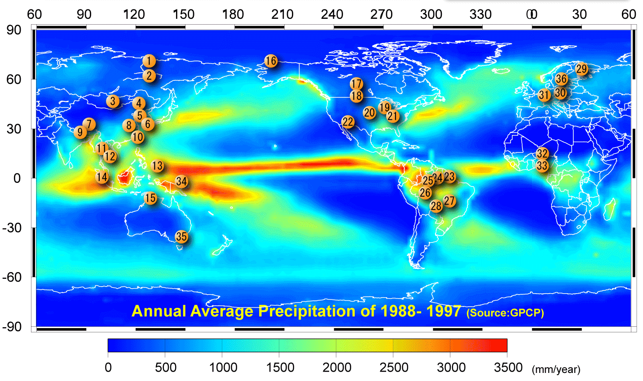

Satellite data from JAXA, NASA, ESA and Eumetsat.
Satellite data scenes are subset to 2.5 degree by 2.5 degree (about 250 by 250 km) centered over the 35 reference sites.
Currently available are (many more in the future):
TRMM PR - precipitation rate (at 80 levels)
TRMM TMI – brightness temperature
AMSRE – soil moisture, precipitation, snow extent (by algorithm) and brightness temperature.

4 types of in-situ data sets
Surface | Tower | Soil | Flux
Station Pressure | Station Pressure | Soil Temperature | Sensible Heat Flux
Air Temperature | Air Temperature | Soil Moisture | Latent Heat Flux
Dew Point Temperature | Dew Point Temperature |  | CO2 Flux
Relative Humidity | Relative Humidity |  | Soil Heat Flux
Specific Humidity | Specific Humidity
Wind Speed | Wind Speed
Wind Direction | Wind Direction
U Wind Component | U Wind Component
V Wind Component | V Wind Component
Precipitation
Snow Depth
Incoming Shortwave
Outgoing Shortwave
Incoming Longwave
Outgoing Longwave
Net Radiation
Skin Temperature
Incoming PAR
Outgoing PAR

Model Output data from 10 agencies (global 3D and MOLTS)
NCEP
UKMO
NASA-GMAO
NASA-GLDAS
JMA
BMRC
ECMWF
NCMRWF
NCMRWF
ECPC
CPTEC/INPE
CMC

MOLTS – Model Output Location Time Series
Time series of model output data values at the model grid point from each model, closest to the center of each reference site.

