Enhancing Use of Surface Observations in IDV
Principal Investigator: John Horel
Institution: University of Utah
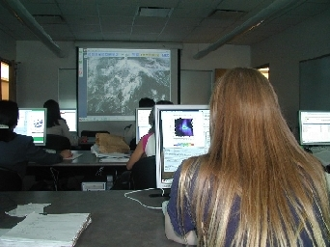
The Department of Meteorology at the University of Utah has actively participated in the Unidata program in a number of ways since its inception. An equipment award from the National Science Foundation in 1997 provided workstations for our student computer laboratory. However, the core infrastructure periodically updated after that time and used to access, process, and deliver the Unidata data streams for classroom and research applications had become complicated, cumbersome, and obsolete. In addition, installation of new equipment and maintenance of existing equipment had overwhelmed our in-house information technology staff.
Department of Meteorology’s student computer laboratory
Support from the Unidata 2007 Equipment Award program provided the spark for a complete redesign of our department’s computational infrastructure during the past year. That redesign is leading to a transition from in-house technical support to staff support from the University’s Center for High Performance Computing (http://www.chpc.utah.edu) for the entire department, including access to and delivery of real-time data. The installation and maintenance of Unidata software by staff unfamiliar with the nuances of LDM and other products has worked better than expected. Due to the broadening of the scope of our efforts from shoring up our real-time data stream to improved computational resources for the department as a whole, some of our target goals for this project remain to be completed this summer. Most critically, a THREDDS data server to provide real-time and retrospective access to surface mesonet observations and surface analyses for the entire Unidata community remains to be completed.
Integrating automated surface observations from as many sources as possible with analysis and forecast model output, as well as satellite and radar imagery, is critical for students to visualize and understand the impacts of weather where it matters, the earth’s surface. Access to surface observations from mesonets is particularly useful for assessing such weather impacts. Although surface mesonet data streams are available via a number of protocols (e.g., web portals, ftp, LDM, OPeNDAP), access to them in IDV remains awkward. There is no THREDDS/IDD archive in place to store and provide direct access to the data seamlessly to the Unidata community via IDV. We intend to continue to work towards providing improved access to surface mesonet observations and will update the Unidata community on that effort later.
Not surprisingly, since we delayed buying hardware until winter 2008 and leveraged our purchases as part of a larger order, the purchasing power afforded by the Unidata funds was greatly enhanced. Instead of dual-dual CPUs, we were able to upgrade to dual-quad CPUs with greater memory. A 10-Tbyte disk array specifically intended for real-time data delivery was purchased in part with Unidata funds along with an additional 40-Tbytes for research and general department use. The new paradigm for our department’s computing infrastructure requires migrating from our present met.utah.edu domain to the chpc.utah.edu domain. Transition of all workstations in the student computer laboratory will be completed prior to the Fall 2008 semester. Migration of the real-time servers is underway, including the completed installation of three dual-quad CPUs with specific functions:
- the IDD server, which processes and archives the Unidata data streams to the real-time data archive
- the MesoWest surface mesonet MySql database server
- the real-time web server for instructional and public service use, including eventual THREDDs data delivery
Web delivery of real-time weather data is being significantly improved through a redesign of our web page by CHPC staff. The new home for our real-time weather products is http://weather.utah.edu , which will include more intuitive access for students and the public to model graphics. The functionality of these web pages should be greatly enhanced by the beginning of Fall 2008 semester.
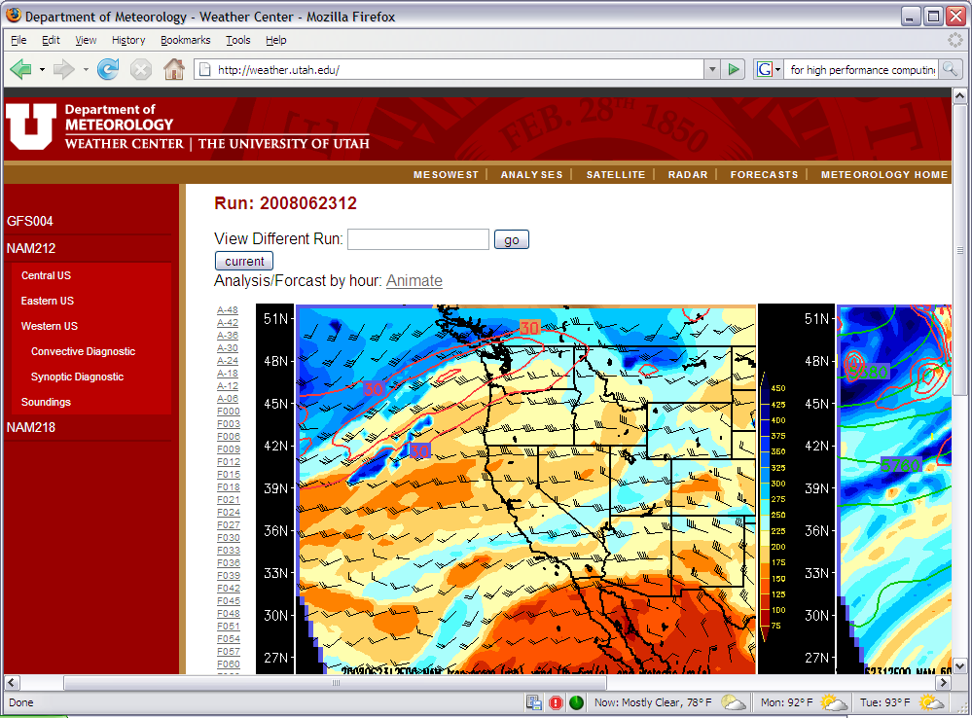 A new look and feel for our real-time “Weather Center” with significant improvements at the server level is under development. See http://weather.utah.edu

