Central Michigan University Equipment Award Report

Marty Baxter and Leigh Orf, Central Michigan University

With funds received from a 2007 Unidata Equipment award, 4 Dell Optiplex 745 2.66 Ghz dual-core machines were purchased to establish a new research lab for undergraduate meteorology students. This lab provides students with the resources necessary for them to work on research projects and coursework when our often used teaching lab is occupied. The new research lab has the Integrated Data Viewer (IDV), GEMPAK, and the N-PROGS installed, and the students can access their home directories just as they do in the teaching lab.

To further encourage use of the new equipment and Unidata products, Dr. Baxter has developed a new course at CMU entitled, “Computer Applications in Meteorology”. This course improves student’s skills in the Linux environment and focuses on aspects of data formats, the IDV, command-line and scripted GEMPAK, and scientific communication. Students are able to work with a large amount of real-time data accessed through the Local Data Manager (LDM) running on a server purchased from a prior Unidata Equipment award, but currently can only access a small amount of case study data archived at CMU. With funds from the Unidata Equipment award, 4 TB of disk storage was purchased to increase the amount of disk space available for case study archival.

Drs. Baxter and Orf have been working to improve access to case study data using IDV through their roles as members of the IDV Steering Committee and the Unidata Users Committee, respectively. Many members of the Unidata community have used the COMET case study library in the classroom, which features data in GEMPAK format accessible through GARP. Using THREDDS (Thematic Realtime Environmental Distributed Data Services) and ADDE (Abstract Data Distribution Environment) servers, we have made GEMPAK model data, satellite data, and surface data from the March 1993 Storm of the Century available to remote users. Rather than provide students with paper documents that instruct them on which buttons to click to answer a question, the lab exercise now takes the form of a web page which provides IDV bundles that will allow for easier interrogation of the data. This reduces the amount of time students must spend on the interface to the data, and gives them more time to think about the relevant meteorological processes. We received considerable assistance from the both the THREDDS and IDV developers through support requests. Dr. Orf gave a presentation at the May 2008 Unidata Users committee documenting our experience in developing the case study.

The case study provides an introduction to the relevant synoptic scale features of the storm and is targeted to the sophomore/junior level. The case can be accessed by specifying the following URL within the IDV’s Data Chooser:

http://dendrite.cst.cmich.edu/SOC_IDV/SOC_IDV.html

The current case study is proof of concept. While we have shown it is possible to view a case study using IDV with GEMPAK data served through THREDDS, performance is slower than we would like, especially when one's data is not on the local network. The use of IDV for case studies allows for considerable more flexibility with respect to the types of data that can be incorporated, as IDV will accept data in many different formats without the need for conversion to a common data type. The IDV also allows for effective inclusion of gif images, text notes, and vector drawings to annotate data. Our work demonstrates that COMET case studies can be converted for use with the IDV, and that a repository for use by remote users could be created.

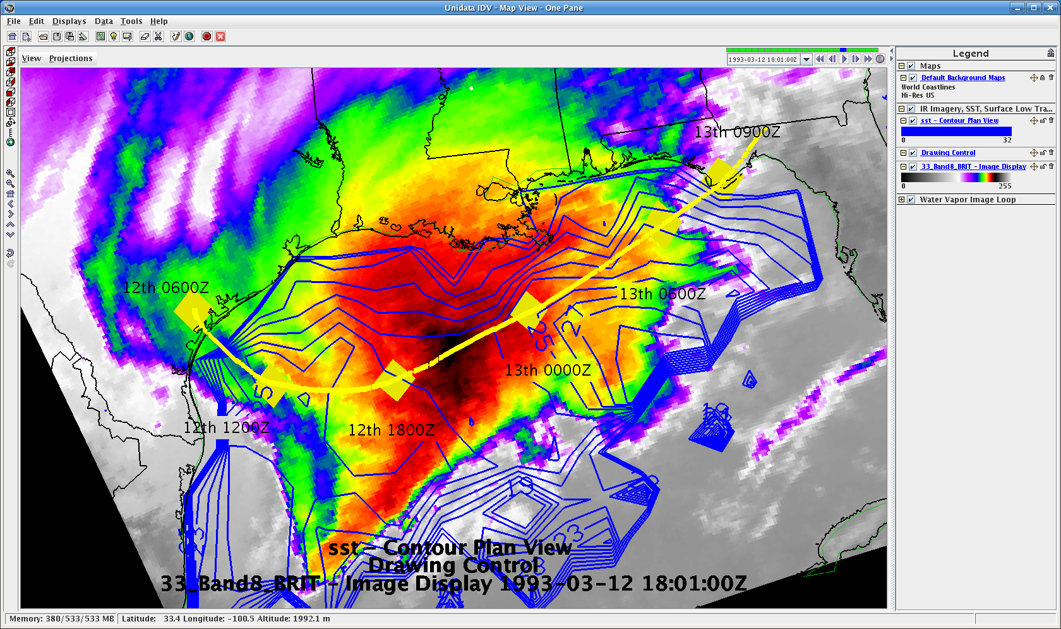

Infrared imagery for 18 UTC 12 March 1993 with AVHRR Pathfinder satellite sea surface temperature data from the National Oceanographic Data Center valid 9 March 1993, and surface low track overlay.

