Enhancing Meteorology Education, Atmospheric Science Research, and

Educational Outreach at the University of Missouri-Kansas City

Unidata EQUIPMENT GRANT REPORT
March 1, 2007

Dr. Jimmy Adegoke

Department of Geosciences
University of Missouri Kansas City
5100 Rockhill Road,
Kansas City, MO 64110.
adegokej@umkc.edu; 816 235-2978

University of Missouri Kansas City is located in Kansas City Missouri, which forms the core of a bi-state metropolitan area having a total a total population of 1.7 million. The Department of Geosciences at UMKC offers undergraduate programs in geography, geology, and environmental studies. The department also has an MS program in Urban Environmental Geosciences and participates in the UMKC interdisciplinary doctoral degree program (IPhD).
Atmospheric science courses offered in the Department of Geosciences include Introduction to Weather and Climate (Geog 215); Descriptive and Synoptic Meteorology (Geog 319); Satellite Meteorology (Geog 448); and Global Environmental Change (Geog 506). UCAR, through the Unidata program, awarded the department a $19,000 grant in 2006 to upgrade an existing environmental science laboratory with new instructional computers and high end server capability to support instruction in meteorology, scientific research, and educational outreach activities. UMKC provided an additional $7,200 as cost share towards the laboratory upgrade.

The Unidata grant enabled the department to replace six of the twelve Dell OptiPlex GX110 PCs (866 Mhz, 266 Mb RAM, 20 Gig HD) purchased in 2000 with new Dell OptiPlex GX620 Pentium 4 PCs (3.20 GHz, 1 Gb RAM, 80 Gig HD). Six additional computers were purchased with internal the cost share funds contributed by UMKC. All the new computers (Figure 1) have the Unidata Integrated Data Visualization (IDV) installed on them and they are now used to support the laboratory components of our meteorology instructional courses.

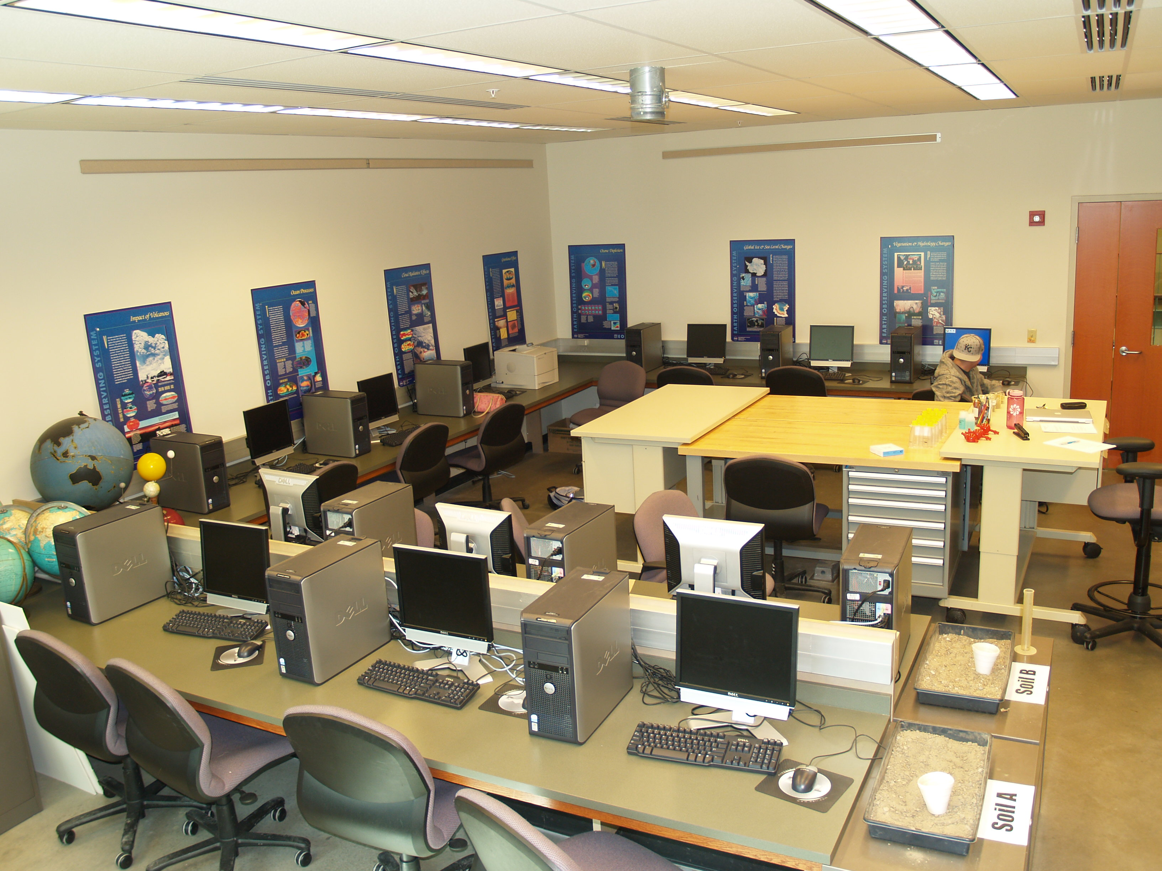
Figure 1: 12 Dell OptiPlex GX110 PCs

The most significant new capability that the Unidata grant made possible was the acquisition of a custom-built high end slackware Linux 10.2 server running the 2.4.32 kernel.
It has 4GB RAM and 700GB RAID1 and 1.4TB RAID5 storage (Figure 2). The server has its own UPS and is housed in one of the secure university computer server rooms that is alarmed and monitored by the Campus police. Communication between the server and the laboratory is via gigabit (1 gigabit per second) connections (with redundant gigabit uplink) of the campus backbone though individual computers in the laboratory are connected to switches with 100 megabit/s ports. Server connection to the Unidata network is via the UMKC 80M connection to the Internet and 90M connection to Internet2.

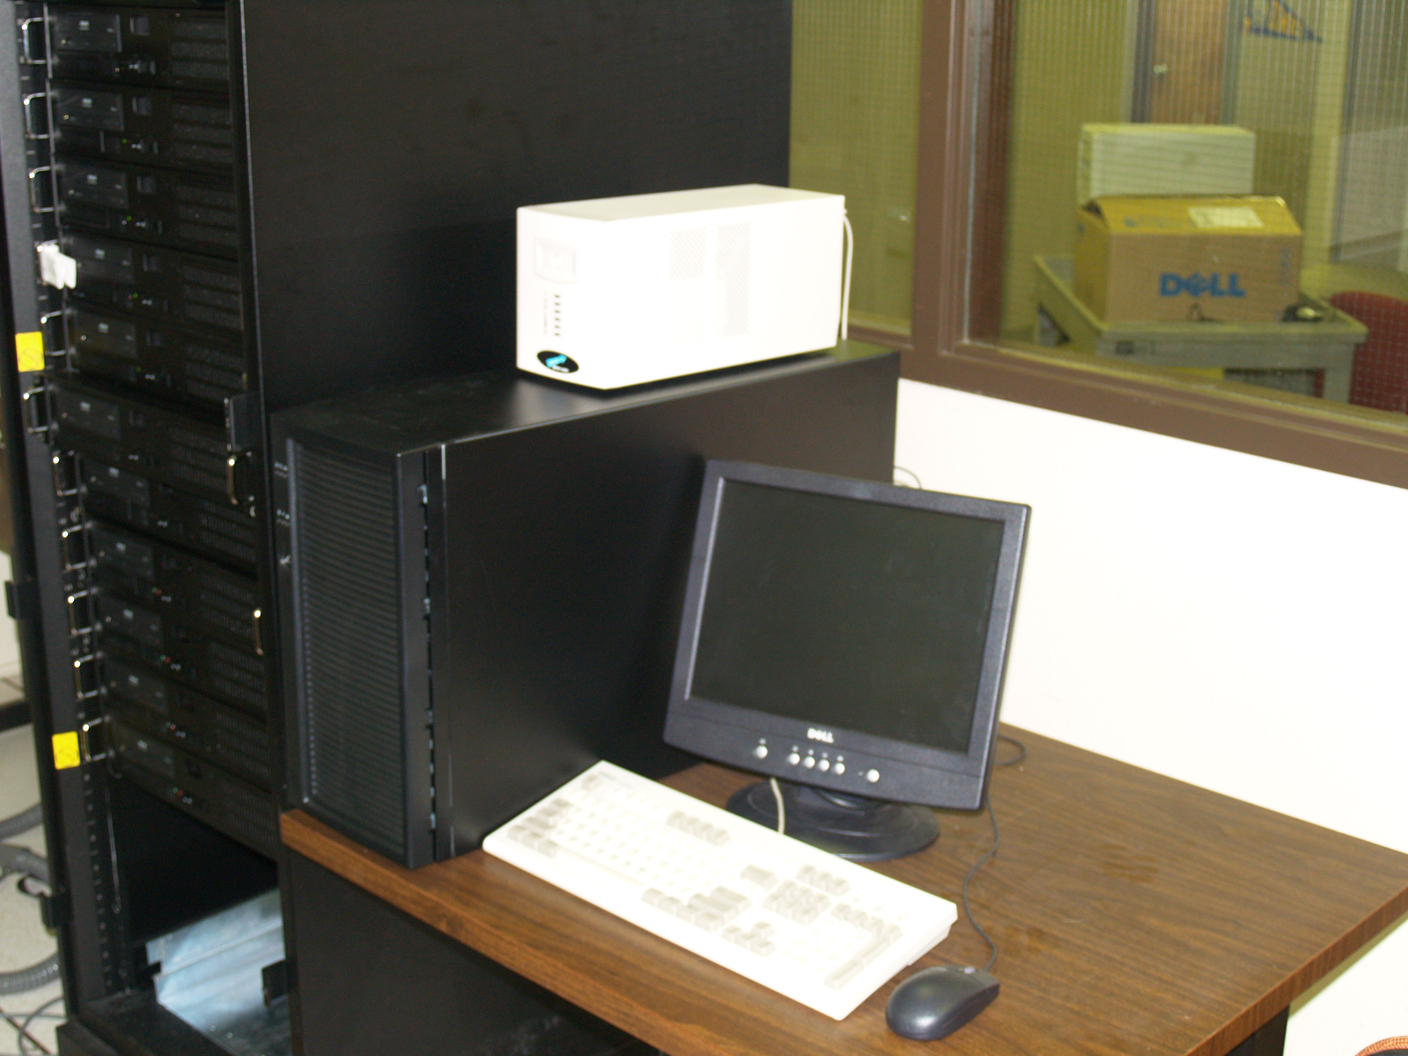
Figure 2: The Slackware Linux 10.2 server with 4GB RAM and 700GB RAID1 and 1.4TB RAID5 storage

These major equipment upgrades have improved our course offerings in meteorology primarily through our enhanced capacity to take advantage of the Unidata program offerings for interactive data-driven instruction and learning. With the new resources for real-time meteorological data ingest and significant storage capability, we are now in a position to archive data for major weather events that come through the Kansas City area for future instructional purposes and use the archived material to develop COMET cases studies, a potential benefit to other members of the Unidata community. Additionally, the new equipment upgrade will enable UMKC to upgrade from our current leaf-node status to a relay site within the Unidata Network by leveraging the UMKC connection to Internet2 traffic, thus directly supporting the expansion of the Unidata Network in the Central US.

Lastly, these Unidata supported enhancements in our laboratory facilities for meteorology and geoscience education have strengthened our geoscience education outreach efforts and improved our ability to attract external funding. For example a recent 4-year NSF grant to the department (PI, Adegoke) will enable us to offer professional development (PD) workshops for high school science teachers designed to enhance their knowledge and the use of inquiry in geoscience content areas. All the data exploration components of the summer PD workshops will be conducted using the resources acquired with the Unidata equipment grant. Furthermore, the new geo-data visualization capability in the upgraded laboratory has the potential to support and enrich our existing summer Minority Outreach Science Enrichment Program (MOSEP) by providing middle school student participants in the program opportunities to use real-time satellite data for inquiry-based learning. In the coming months, we will be using Unidata resources to develop grade appropriate and standards-based curriculum materials for use in our 2007 MOSEP summer camp.

