Service-oriented environments in research and education for dynamically interacting with mesoscale weather

^{1,2}Kelvin K. Droegemeier, ⁷Tom Baltzer, ¹Keith Brewster, ³Richard Clark, ⁷Ben Domenico, ⁴Dennis Gannon, ⁵Sara Graves, ⁶Everette Joseph, ⁶Vernon Morris, ⁷Donald Murray, ⁴Beth Plale, ⁵Rahul Ramachandran, ⁷Mohan Ramamurthy, ⁹Lavanya Ramakrishnan, ⁹Daniel Reed, ⁵John Rushing, ¹Daniel Weber, ⁸Robert Wilhelmson, ⁷Anne Wilson, ^{1,2}Ming Xue, and ³Sepideh Yalda

1Center for Analysis and Prediction of Storms and 2School of Meteorology
University of Oklahoma
Norman, Oklahoma

3Millersville University
Millersville, Pennsylvania

4Indiana University
Bloomington, Indiana

5University of Alabama in Huntsville
Huntsville, Alabama

6Howard University
Washington, DC

7University Corporation for Atmospheric Research
Boulder, Colorado

8National Center for Supercomputing Applications
Urbana, Illinois

9University of North Carolina
Chapel Hill, North Carolina

Submitted to Computing in Science and Engineering
April 2005
1. Introduction
Each year across the United States, floods, tornadoes, hail, strong winds, lightning, and winter storms – so-called mesoscale weather events -- cause hundreds of deaths, routinely disrupt transportation and commerce and result in annual economic losses greater than $13B (Pielke and Carbone 2002). Although mitigating the impacts of such events would yield enormous economic and societal benefits, research leading to that goal is hindered by rigid information technology (IT) frameworks that cannot accommodate the real time, on-demand, and dynamically-adaptive needs of mesoscale weather research; its disparate, high volume data sets and streams; and the tremendous computational demands of its numerical models and data assimilation systems.
In response to this pressing need for a comprehensive national cyberinfrastructure in mesoscale meteorology, particularly one that can interoperate with those being developed in other relevant disciplines, the National Science Foundation in 2003 funded a Large Information Technology Research (ITR) grant known as Linked Environments for Atmospheric Discovery (LEAD). This multi-disciplinary effort involving 9 institutions and some 80 scientists and students is addressing the fundamental IT and meteorology research challenges needed to create an integrated, scalable framework for identifying, accessing, decoding, assimilating, predicting, managing, analyzing, mining, and visualizing a broad array of meteorological data and model output, independent of format and physical location.
A major underpinning of LEAD is dynamic workflow orchestration and data management in a web services framework. These capabilities provide for the use of analysis tools, forecast models, and data repositories not in fixed configurations or as static recipients of data, as is now the case for most meteorological research and operational forecasting technologies, but rather as dynamically adaptive, on-demand, grid-enabled systems that can a) change configuration rapidly and automatically in response to weather; b) continually be steered by new data; c) respond to decision-driven inputs from users; d) initiate other processes automatically; and e) steer remote observing technologies to optimize data collection for the problem at hand. Simply put, LEAD is creating the IT needed to allow people (students, faculty, research scientists, operational practitioners) and atmospheric tools (radars, numerical models, data assimilation systems, data mining engines, hazardous weather decision support systems) to interact with weather. Although mesoscale meteorology is the particular problem to which the above concepts are being applied, the methodologies and infrastructures being developed are extensible to other domains such as medicine, ecology, oceanography and biology.
LEAD is targeted principally toward the meteorological higher education and research communities. However, it also is developing learning communities, centered around teacher-partners and alliances with educational institutions, to bring the benefits of LEAD to grades 6-12. The deployment of LEAD is being orchestrated via a phased approach involving a number of test beds and strategic partners, one of which is the University Corporation for Atmospheric Research (UCAR) Unidata program (UPC 20902, 2005). Unidata provides near-real time access to atmospheric data for more than 150 organizations encompassing 21,000 university students, 1800 faculty, and hundreds of operational practitioners. Unidata also provides freely available tools and middleware to support atmospheric research and education that are used directly by thousands of users and indirectly on a much larger scale. Another is the nascent numerical weather prediction Developmental Test Bed Center (DTC) at the National Center for Atmospheric Research. The DTC, sponsored by the NSF and National Oceanic and Atmospheric Administration, provides a national collaborative framework in which numerical weather analysis and prediction communities can interact to accelerate testing and development of new technologies as well as techniques for research applications and operational implementation – all in a way that mimics, but does not interfere with, actual forecast operations. It is anticipated that the DTC will become the focal point for mesoscale model experimentation and the transfer of new concepts and technologies into operational practice.
2. The Case for Dynamic Adaptation
a. Limitations in Studying Mesoscale Meteorology
Those who have experienced the devastation of a tornado, the raging waters of a flash flood, or the paralyzing impacts of lake effect snows understand that mesoscale weather develops rapidly with considerable uncertainty in location. Such weather also is locally intense and frequently influenced by processes on both larger and smaller scales. It therefore is ironic that most technologies used to observe the atmosphere, predict its evolution, and compute, transmit and store information about it operate not in a manner that accommodates the dynamic behavior of mesoscale weather, but rather as static, disconnected elements. Radars do not adaptively scan specific regions of storms, numerical models are run on fixed time schedules in fixed configurations, and cyberinfrastructure does not allow meteorological tools to be run on-demand, change their configuration in response to the weather, or provide the fault tolerance needed for rapid reconfiguration. As a result, today’s weather technology, and its use in research and educational, are highly constrained by IT infrastructure and are far from optimal when applied to any particular situation. This is the first principal limitation that LEAD is addressing.
The second limitation involves the experimental simplicity imposed by enormously complex mesoscale models and the cyber environments needed to support them. Such models, representing numerous physical processes and in some cases coupled with hydrologic and oceanographic models, are freely available and, with the availability of powerful local computers, are being run daily by dozens of universities, Federal research laboratories, and even private companies. Unfortunately, owing to the complexity of and the human capital needed to manage real time data streams, multiple and frequently changing data formats, and complex data ingest, processing, and forecasting software, most experimentation is highly simplified and involves initializing models using pre-processed analyses from the National Weather Service (NWS). Consequently, the primary research benefit of experimental forecasts – encompassing the use of much finer model grid spacings, special data sets, and more sophisticated dynamical and physical frameworks than those employed operationally by the NWS – especially those focused on local regions, frequently is lost.
b. Adaptation in Time
To demonstrate the potential benefits of adaptability and a cyberinfrastructure that supports complex forecast systems, Figure 2.1 shows radar reflectivity (equivalent to precipitation intensity) from the Wichita, Kansas WSR-88D (NEXRAD) Doppler weather radar at 0336 UTC (10:36 pm CDT) on 21 June 2001. Clearly evident is a broken line of intense thunderstorms (dark red colors) oriented northeast-southwest extending from just southwest of Topeka to south of Great Bend. A second area of storms is present in northern Oklahoma. Just after noon that same day, a private electric utility in Kansas, which was controlling its own customized version of a fine-scale prediction model operated by Weather Decision Technologies, Inc., generated the 11-hour forecast shown in Figure 2.2a, i.e., initiated at 11 am CDT and valid at 10 pm CDT, or approximately 38 minutes prior to the radar image in Figure 2.1.
The forecast depicts an area of thunderstorms having roughly the same alignment as what eventually developed (compare Figures 2.1 and 2.2a). However, before mobilizing repair crews to deal with possible power outages, the utility chose to modify the model’s execution schedule and run a rapid update cycle, producing forecasts every 2 hours (Figures 2.2b-d, with the 7-hour forecast not shown). Although the 9-hour forecast (Figure 2.2b) produced a noticeably different solution, the model began to “lock onto” a consistent solution as the valid time (10 pm CDT) approached, giving the utility confidence in the outcome and sufficient lead time to mobilize a response.
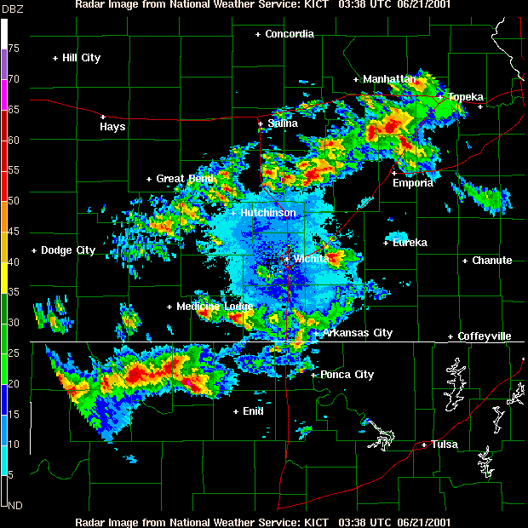

Figure 2.1. Radar reflectivity (proportional to precipitation intensity) from the Wichita, Kansas WSR-88D (NEXRAD) radar valid at 0036 UTC (10:36 pm CDT) on 21 June 2001. Warmer colors indicate greater intensity.

b. Adaptation in Space
In addition to running a model more frequently in time in response to rapidly changing weather conditions, adaptation can occur in space via the use of adaptive grids. This modality of computation is quite common across a wide range of fluid dynamics applications and has been automated so that the grid mesh responds dynamically to changes in the flow using both structured (e.g., Skamarock and Klemp 1993) and unstructured (e.g., Dietachmayer and Droegemeier, 1992) approaches.
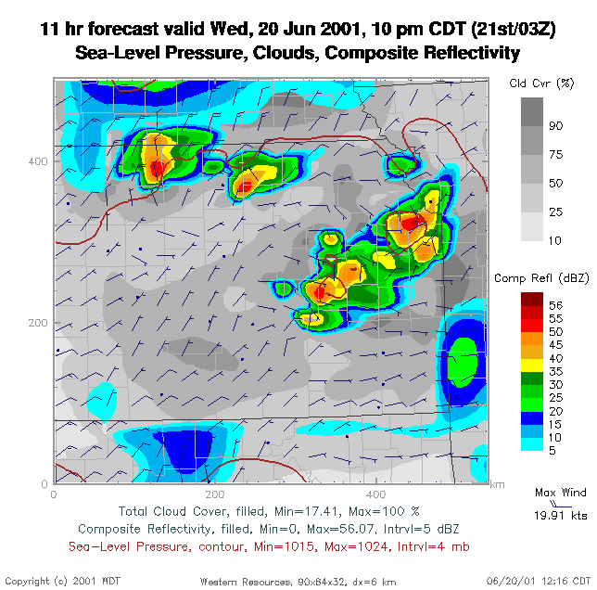
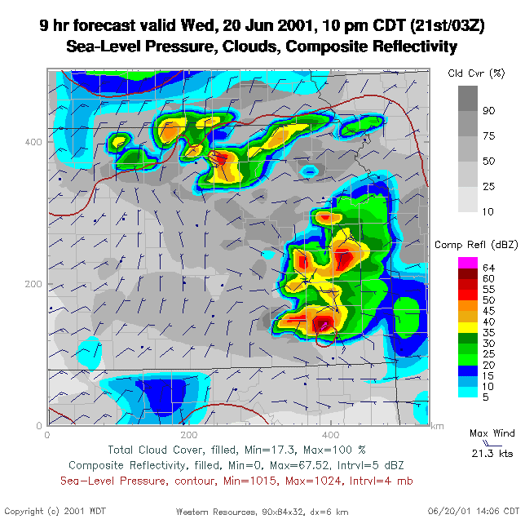
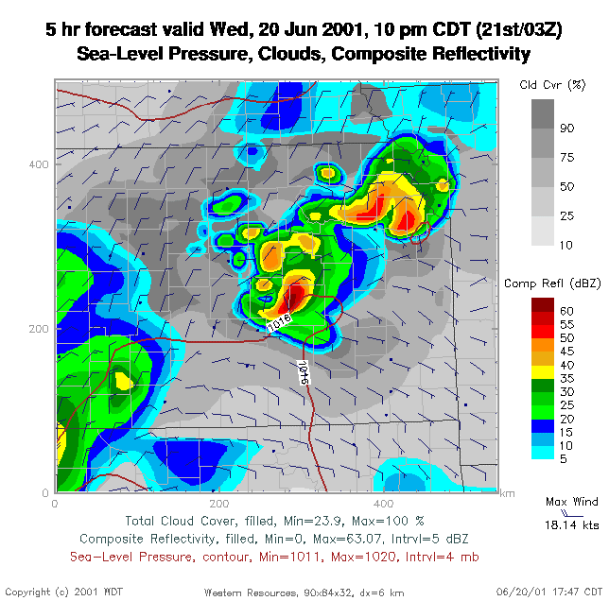
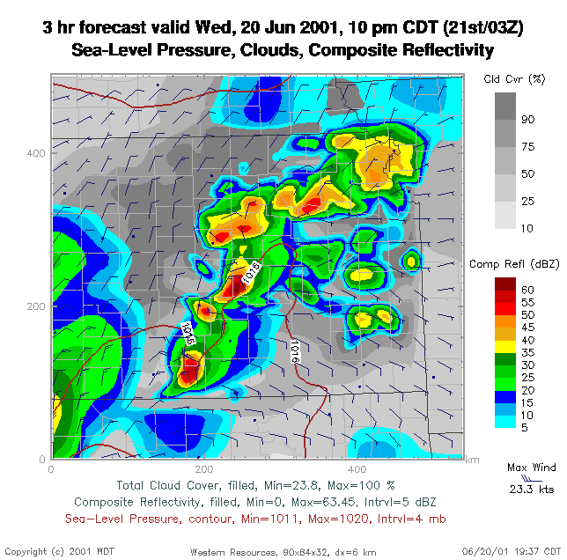
a
b
c
d

Figure 2.2. Radar reflectivity forecasts from the Center for Analysis and Prediction of Storm’s Advanced Regional Prediction System (ARPS), produced by Weather Decision Technologies, Inc. on 20 June 2001. Forecast lead time is shown at the top of each image and warmer colors indicate greater precipitation intensity.

In the context of atmospheric modeling and prediction, spatial grid refinement is motivated by the desire to capture increasingly fine scale features, particularly individual thunderstorms, simultaneous with their larger scale environments. To illustrate, Figure 2.3 shows a 12-hour radar reflectivity forecast from the ARPS, valid at 0000 UTC (6:00 pm CST) on Friday, 29 January 1999, using a horizontal grid spacing of 32 km (see also Xue et al. 2003). The northeast-southwest oriented region of precipitation in Arkansas, which has little structure in the model owing to the coarse grid, contains in reality multiple lines of tornadic thunderstorms (Figure 2.4).

Figure 2.3. 12-hour radar reflectivity forecast from the Center for Analysis and Prediction of Storm’s Advanced Regional Prediction System (ARPS), valid at 0000 UTC on 22 January 1999 (6:00 pm CST on 21 January 1999), using 32 km horizontal grid spacing. The red box indicates the location of the 9 km nested grid shown in Figure 2.5.
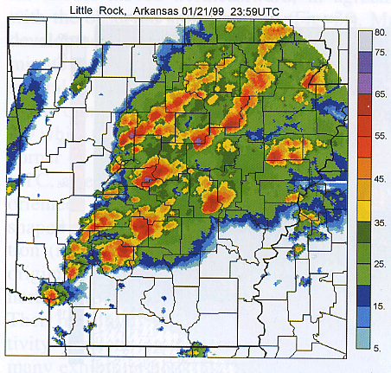

Figure 2.4. As in Figure 2.1, but at 2359 UTC (5:59 pm CST) on 21 January 1999 over Arkansas from multiple radars with their data objectively analyzed to a regular grid. From Xue et al. (2003).

In an attempt to capture more detail, a nested grid using 9 km horizontal spacing (red box in Figure 2.3) was spawned over the region of interest and yielded the 6-hour forecast shown in Figure 2.5. Some explicit evidence of deep thunderstorms is beginning to emerge, though the 9 km grid is unable to resolve the most energetic elements of the flow, i.e., individual updrafts and downdrafts. Spawning yet another grid at 3 km spacing (Figure 2.6), indicated by the red box in Figure 2.5, yields a forecast that captures the multiple line structure, overall orientation and generally correct movement of the storms (compare Figure 2.4). Upon close inspection, however, the 3 km forecast does differ from observations in important ways (e.g., the lack of storms in the “boot heel” of and in eastern Missouri). Nevertheless, the ability to spatially adapt the grid mesh (in this case manually) clearly provides a positive impact.

Figure 2.5. As in Figure 2.3 but a 6-hour nested grid forecast using 9 km horizontal grid spacing. The red box indicates the location of the 3 km nested grid shown in Figure2.6.
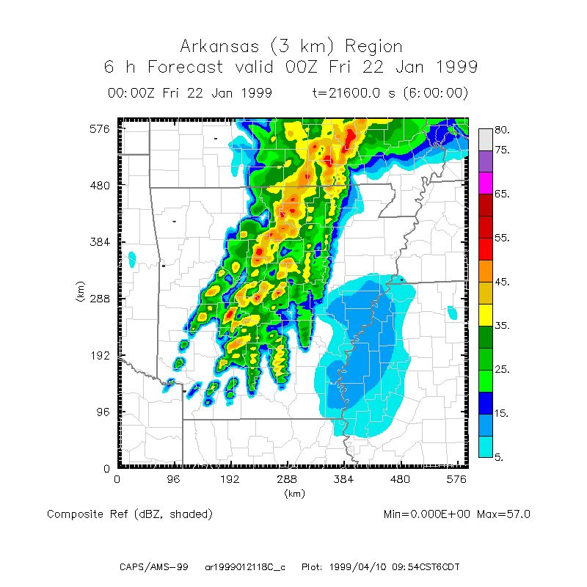

Figure 2.6. As in Figure 2.5 but a 6-hour nested grid forecast using 3 km horizontal grid spacing over the domain shown by the red box in Figure 2.5.

c. Ensemble Forecasting
Comparing Figures 2.1 and 2.2, it is clear that any given forecast, particularly of thunderstorms, can contain considerable uncertainty, in large part because one never knows the true state of the atmosphere. Consequently, the initial condition of a particular numerical forecast represents only one of numerous possibilities, i.e., a single member of a probability distribution of physically plausible initial conditions. Because insufficient computational power exists to predict the evolution of the full distribution (known as stochastic-dynamic forecasting, e.g., Fleming 1971a,b), meteorologists sample from it a number of states (initial conditions) and instead of making a single forecast they produce numerous forecasts. This so-called ensemble methodology – or the creation of multiple, concurrently valid forecasts from slightly different initial conditions, from different models, from the same model initialized at different times, and/or via the use of different physics options within the same or multiple models – has become the cornerstone of medium-range (6-10 days) operational global numerical weather prediction (NWP) (e.g., Kalnay 2003) and now is being extended to individual storms (Kong et al. 2005). Of course, ensemble forecasting greatly increases the required computational resources and thus may be desirable only in certain situations – as dictated by the weather or by the outcome of a provisional forecast; thus, the need for intelligent, automated adaptation.
To illustrate the power of ensemble forecasting, Figure 2.7 shows radar reflectivity at 0000 UTC (6 pm CST) on 29 March 2000 over north central Texas, similar in content to Figure 2.1 though from multiple radar data objectively analyzed to a regular grid. Clearly evident is a north-south oriented line of intense supercell thunderstorms that produced multiple tornadoes, one of which passed through the Fort Worth, Texas metropolitan area (white arrow) causing three deaths and nearly half a billion dollars in damage (NCDC 2000). A five-member
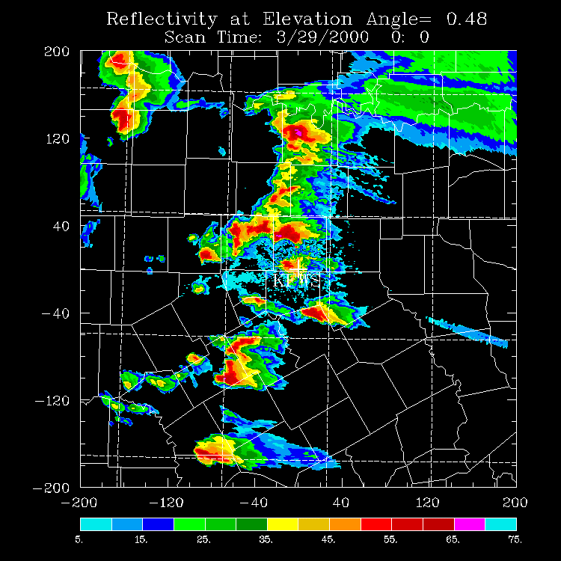

Figure 2.7. As in Figure 2.4, but at 0000 UTC (6 pm CST) on 29 March 2000 over north central Texas from multiple radars. The white arrow shows the supercell that produced a major tornado in the Fort Worth, Texas metropolitan area.

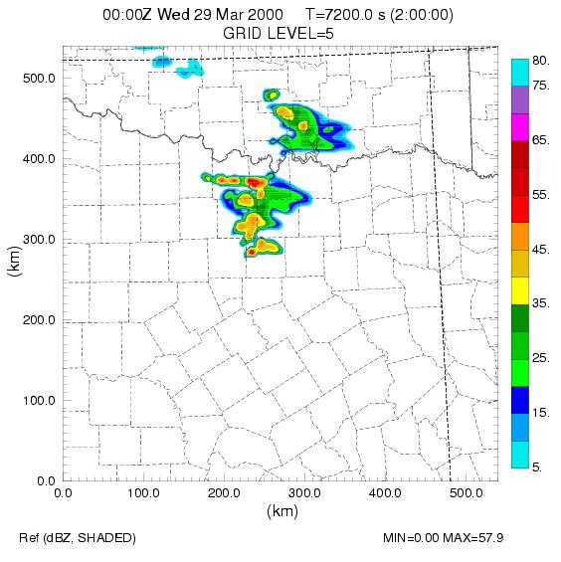
Control Forecast

Figure 2.8. Two-hour radar reflectivity forecast from the ARPS, representing the control run of a 5-member ensemble, valid at 0000 UTC on 29 March 2000. Warmer colors indicate greater precipitation intensity.

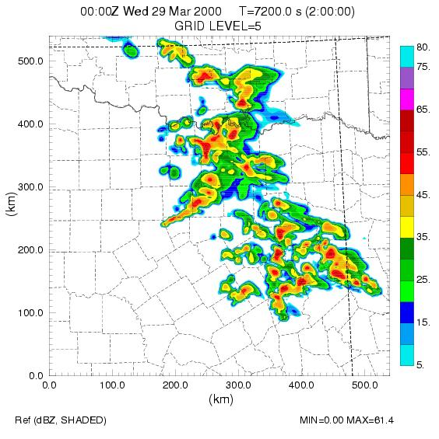
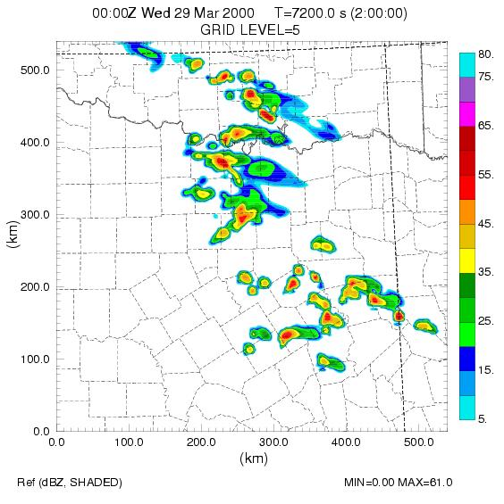
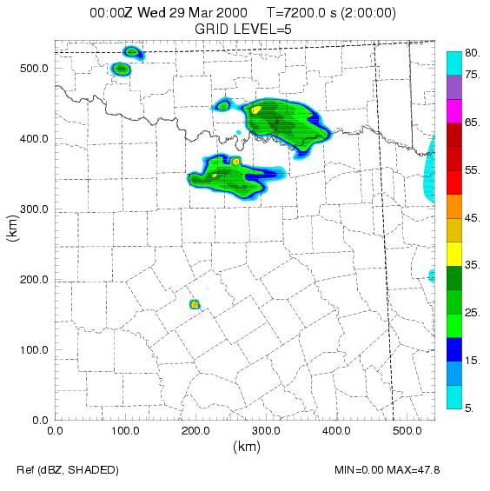
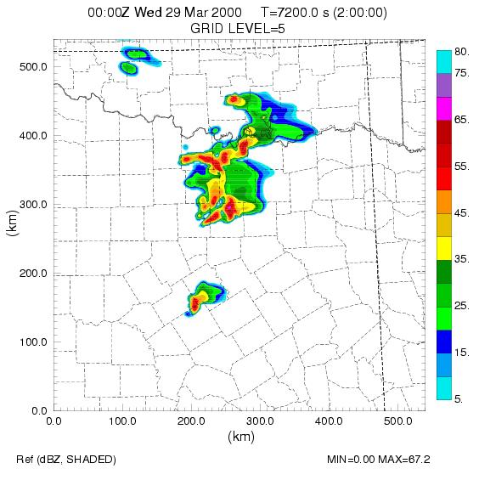
ARPS ensemble was initialized at 2300 UTC on 29 March 2000 and the 2-hour control forecast is shown in Figure 2.8. It captures the overall structure and motion of the storms in northern Texas but fails to predict the extension of the system farther south (compare Figure 2.7). The other four ensemble members, initialized from slightly different states and valid at the same time (Figure 2.9), exhibit considerable variability, with members 1 and 2 placing an extensive area of spurious
Ensemble Member 1
Ensemble Member 2
Ensemble Member 3
Ensemble Member 4

Figure 2.9. As in Figure 2.4, but from the four ensemble members corresponding to the control forecast.
storms in the southeastern part of the domain. Member 3 is different from all other forecasts as well as reality (Figure 2.7), and if this happened to be the only forecast available, the guidance obviously would be quite poor.
The ability to launch an ensemble of forecasts automatically, and to determine the size of the ensemble and thus the computational and networking load dynamically based upon the output of a control run (which in this case indicated the likelihood of intense thunderstorms and possible tornadoes), represents a significant adaptation to both observations and model output. The practical value of ensemble forecasting lies in the ability to quantify forecast uncertainty, and emphasize intense local events, through the use of probabilities. Figure 2.10 shows the probability of radar reflectivity exceeding a value of 35 dBZ (heavy precipitation). This calculation simply involves
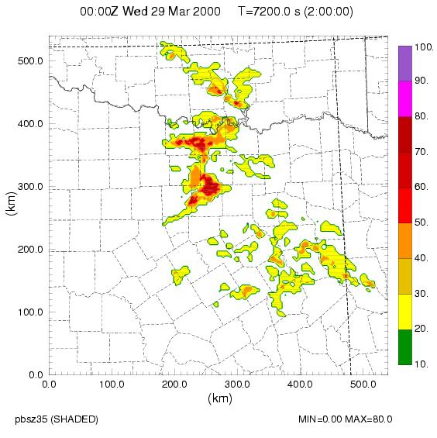

Figure 2.10. Probability of radar reflectivity >35 dBZ based upon the 5 member ensemble shown in Figures 2.8 and 2.9. Compare with actual radar reflectivity in Figure 2.7.

determining, at each grid point, how many forecasts meet this criteria and then dividing by the total number of forecasts. Note how the ensemble de-accentuates the incorrect storms in the southeastern part of the domain and highlights the region where all forecasts agreed – near Fort Worth, where the tornadic storms occurred.
d. Adaptive Observing Systems

For the most part, deployment strategies for atmospheric remote sensing platforms have emphasized spatially regular instrument arrays that are fixed in space, collect observations at prescribed intervals, and operate largely independently – and in the same mode – regardless of the type of weather being interrogated. A prime example is the national WSR-88D (NEXRAD) Doppler weather radar network. Owing to the long range of these radars, Earth’s curvature prevents approximately 72% of the atmosphere below 1 km from being sampled. Furthermore, the radars have only a few modes of operation and cannot be tasked to focus on specific regions of the atmosphere at the expense of others.
In recent years, conventional observing strategies has been supplemented by adaptive or targeted observations in which sensors are deployed to specific areas – usually in the middle and upper troposphere – where additional information most likely will improve forecast quality (e.g., Morss et al. 2001 and references therein). Examples include instruments dropped from aircraft and deployed on unmanned aerial vehicles. Although valuable, these strategies sample only a very tiny fraction of the atmosphere and are not suited for providing fine-scale, volumetric data in the interior of thunderstorms – a domain of remote sensing exclusive to Doppler radar.
To address this problem, the NSF funded in 2003 the Engineering Research Center for Collaborative Adaptive Sensing of the Atmosphere (CASA; McLaughlin et al. 2005). CASA seeks to revolutionize the sensing of the lowest 3 km of the atmosphere by developing inexpensive, low-cost, low-power Doppler radars that can be located on existing infrastructures such as cell towers and buildings. Deployed in dense arrays, these radars are designed to collaborate with one another in real time, adaptively sensing multiple phenomena while simultaneously meeting multiple end user needs – all in an optimal manner. CASA represents the principal adaptive observing technology for application to LEAD, and a 4-radar test bed in central Oklahoma will become operational in early 2006.
e. Adaptive Cyberinfrastructure

Achieving the types of adaptation demonstrated in previous sections requires a flexible, fault tolerant, dynamic cyberinfrastructure that can rapidly be reconfigured automatically at the direction of remote sensors, models, and users. High performance computing and storage resources must be made available with little advance notice in response to changing forecast configurations and observations, and data analysis and mining components must detect faults, allow incremental processing (interrupt/resume) and estimate run time and memory requirements based upon evolving data properties. Owing to the highly perishable nature of the information being gathered and generated, network bandwidth must be made available on demand to transfer huge data sets and output files, and sufficient monitoring and quality of service guarantees must be available to support real time experimentation and decision making, especially in a classroom setting.
f. Managing the Forecast and Simulation Process

Only a few academic institutions have the software infrastructure needed to automate the forecast process shown above. One is the University of Oklahoma and its Center for Analysis and Prediction of Storms (CAPS), a now-graduated first generation NSF Science and Technology Center that pioneered the science of thunderstorm prediction using numerical models. The software that manages its real time forecast environment (http://caps.ou.edu/wx) consists of 50,000 lines of Perl code. Though sophisticated and powerful, it requires considerable programming expertise and presents a huge barrier for graduate and undergraduate students as well as other users. The LEAD workflow environment, described in section 6, greatly simplifies the forecasting process through the use of graphical user interfaces and workflow task graphs.
3. System Capabilities
LEAD comprises a complex array of services, applications, interfaces and local and remote computing, networking and storage resources (Figure 3.1) – so-called environments – that are assembled by users in workflows (section 6) to study mesoscale weather as it evolves. From the high-level view of a user (top bar in Figure 3.1), LEAD allows one to query for and acquire information (e.g., observational data sets, model results, the status of a resource or job), simulate and predict using numerical atmospheric models, assimilate data (i.e., combine observations, under imposed dynamical constraints, to create a 3D atmospheric state), and analyze, mine and visualize data and model output. The outcomes of these operations (bottom bar in Figure 3.1) include data sets, model output, gridded analyses, animations, static images, and a wide variety of relationships and other information that leads to new knowledge, understanding and ideas. The fabric that links the top set of requirements with the bottom set of outcomes – namely, the extensive middleware, tool and service capabilities – is the research domain of LEAD.
A number of foundational tools are provided within the LEAD environments (second bar in Figure 3.1), including a web portal, which serves as the primary though not exclusive user entry point; the ARPS Data Assimilation System (ADAS; Brewster 1996), a sophisticated tool for data quality control and assimilation including the preparation of initial conditions for simulations and forecasts; MyLEAD (Plale et al. 2004), a flexible meta data catalog service; the Weather Research and Forecast model (WRF; Michalakes et al. 2000), a next-generation atmospheric prediction and simulation model; ADaM (Algorithm Development and Mining; Rushing et al. 2005), a powerful suite of tools for mining observational data, assimilated data sets and model output; and IDV (Integrated Data Viewer; Murray et al. 2003), a widely used desktop application for visualizing, in an integrated manner, a wide variety of multi-dimensional geophysical data. As described in section 5, the foundational capabilities and the tools that enable them are linked together within a service-oriented architecture.

Figure 3.1. Schematic of LEAD system capabilities.
4. System Concept
The philosophical underpinning of LEAD is WOORDS – Workflow Orchestration for On-Demand, Real-Time, Dynamically-Adaptive Systems. WOORDS expressions the notion of users creating, managing, and altering workflows, dynamically and automatically in real time, in the context of systems that adapt themselves to changing circumstances such as weather. As used in LEAD, the components of WOORDS have the following meaning:
- Workflow Orchestration -- The automation of a process, in whole or part, during which tasks or information are passed from one or more components of a system to others -- for specific action -- according to a set of procedural rules.

- On-Demand – The capability to perform action immediately with or without prior planning or notification.

- Real-Time -- The transmission or receipt of information about an event nearly simultaneous with its occurrence, or the processing of data or execution of other commands in step with wall clock time.

- Dynamically-Adaptive – The ability of a system, or any of its components, to respond automatically, in a coordinated manner, to both internal and external influences in a manner that optimizes overall system performance.

- System – A group of independent but interrelated elements that operate in a unified holistic manner.

Although mesoscale meteorology and numerical weather prediction represent perhaps archetypal applications of WOORDS, the concept is far more general. As an example, effective suppression of wild land fires will in the future depend upon numerical simulations that use evolving conditions of weather, fuel availability, the location of burn lines, etc. Additionally, embedded sensors that measure roadway conditions and highway traffic flow will in the future be able to reroute traffic so as to optimize throughput based upon models that input continually changing conditions. These and other examples show the importance of LEAD evolving WOORDS as a general notion – a paradigm of broad applicability – from which the non-meteorology community can benefit.
The LEAD system, shown schematically in Figure 4.1, consists of the following principal components:

Figure 4.1. LEAD system framework.

- User Sub-System – Consists of the LEAD portal, which is the principal, though not only mechanism by which users can access LEAD technologies, along with the myLEAD personal work space and the Geo-reference graphical user interface.

- Data Sub-System – Handles data and meta data including ingest, cataloging, searching, describing, visioning and storage management of observations (real time streaming, archived, experimental or operational), numerical model output produced by operational or experimental models, and user-generated information.

- Tools Sub-System – Consists of all meteorological and IT tools including but not limited to the WRF model, ADaM, ADAS, data decoders, and interfaces for user-supplied tools.

- Orchestration Sub-System – Provides the technologies that enable users to manage flows of data and model execution streams, as well as create and mine output. It further provides linkages to other software and processes for continuous or on-demand application, including the steering of remote observing systems.

- Grid and Web Services Test Beds – Located at five of the nine participating institutions, these distributed computing systems represent a grid for developing, integrating, and testing all components of LEAD (section 5).

They reflect the manner in which the project itself is organized (Figure 4.2), namely, five parallel and synergistic research thrusts with two cross-cutting test beds. The latter ensure that the former are tightly and continuously integrated, and that end users are involved in the entire development process from the beginning.

Figure 4.2. Organization of LEAD research and development.

5. The LEAD Service-Oriented Architecture

5.1. The Web Service Concept
A service is an entity that carries out a specific operation, or a set of operations, based upon requests from clients, e.g., booking airline flights or looking up the address of a friend. Web Services are networked services that conform to a family of standards, called “WS-*,” that specify most aspects of a service’s behavior and have been developed by a number of organizations including the World Wide Web Consortium (WWWC 2005) and the industry group Oasis (Oasis Consortium 2005). The Web Service Definition Language (WSDL) (WWWC 2005) is used to specify how a service expects to receive requests and the type of responses it generates. WS-Addressing (WWWC 2005) defines the way a client accesses a service and to what location the service should send responses. WS-Security defines protocols for secure communication of messages from the client to the service and back.
There exist approximately a dozen other important standards for web services. A “Service Oriented Architecture” (SOA) refers to a design pattern that is based upon organizing all of the key functions of an enterprise or a system as a set of services. The work of the enterprise or system is carried out by workflows that orchestrate collections of service invocations and responses to accomplish a specific task. SOAs are being deployed widely in the commercial enterprise sector and they form the foundation of many scientific “Grid” technologies.
5. 2 The LEAD Service Architecture
As shown in Figure 5.1, the LEAD SOA is realized as five layers. The bottom layer represents raw resources consisting of computation as well as application and data resources that

Figure 5.1. The LEAD Service Architecture.
are distributed throughout the LEAD testbed and elsewhere. At the next level up are web services that provide access to the raw services including standard services such as those found in Globus (e.g., the Grid resource allocation manager (GRAM) and the Grid file transfer service), as well as services for accessing weather data (LDM; Rew and Davis, 1990 and OpenDAP; http://opendap.org) and the data access services like the Replica Location Service (RLS) (Vazhkudai et al. 2001) and the Open Grid Service Architecture Data Access and Integration service (OGSA-DAI) (Antonioletti et al. 2005).
Configuration and execution services compose the next layer and represent services invoked by LEAD workflows. They are divided into four groups, the first being the application oriented service that manages the deployment and execution of real applications such as the WRF simulation model, the ADAS data assimilation tools and the ADaM data-mining tools. For each of these services are required to track their deployment and execution environment requirements to enable dynamic staging and execution on any of the available host systems. A closely related service is the application resource broker, which is responsible for matching the appropriate host for execution to each application task based upon time constraints of the execution. Both of these services are invoked by the workflow engine service, which drives experimental workflow instances (as described in section 7 below). The third service represents the manner in which a user discovers data for use in computational experiments via a virtual organization (VO) catalog. It does so by indexing the contents of THREDDS catalogs (Davis and Caron 2002), which store pointers to a wide variety of data. Finally a host of data services are needed to search for and apply transformations to data products. An ontology service resolves higher-level atmospheric concepts to specific naming schemes used in the various data services, and decoder and interchange services such as the Earth System Markup Language (ESML; Ramachandran et al. 2004) transform data from one form to another. Stream services manage live data streams such as those generated by the NEXRAD Doppler radar network (with a bandwidth per radar of approximately 14 megabytes per 5 minutes, with 142 radars in the national network)
Several services are used within all layers of the SOA and are referred to as crosscutting services, indicated in the left column of Figure 5.1. One such service is the notification service, which lies at the heart of dynamic workflow orchestration. Each service is able to publish notifications and any service or client can subscribe to receive them. This strategy is based upon the WS-Eventing standard (Box et al. 2004), where notifications signal the completion of tasks, the failure of some job or an immediate command from a user. Another critical component is the monitoring service, which is discussed in section 8. Monitoring provides, among other things, mechanisms to ensure that desired tasks are completed by the specified deadline – an especially important issue in weather research.
A vital crosscutting service that ties multiple components together is the user metadata catalog known as myLEAD. As an experiment runs, it generates data that are stored on the LEAD Grid and catalogued to the user’s myLEAD metadata catalog (Figure 6.1). Notification messages generated during the course of workflow execution also are written to the metadata and stored on behalf of a particular user. A user accesses metadata about the products used during or generated by an experimental investigation through a set of metadata catalog-specific user interfaces built into the LEAD Portal. Through these interfaces the user can browse holdings, search for products based on rich meteorological search criteria, publish products to broader groups or to the public, snapshot an experiment for archiving, or upload text or notes to augment the experiment holdings (Lee et al. 2005). Authentication and authorization are handled by specialized services based upon Grid standards.
Finally, at the top level of the architecture in Figure 5.1 is the user interface to the system. This consists of the LEAD web portal and a collection of “service-aware” desktop tools. The portal, described below, is a container for user interfaces, called portlets, that provide access to individual services. When a user logs into the portal, his or her grid authentication and authorization credentials are loaded automatically. Each portlet can use these identity certificates to access individual services on behalf of the user, thus allowing users to command the portal to serve as his or her proxy for composing and executing workflows on back-end resources.
Alternatively, users may access services by means of desktop tools. For example, the Integrated Data Viewer (IDV) can access and visualize data from a variety of sources including OPenDAP. A WRF configuration tool can be used to set physical and computational parameters of the WRF for upload to the portal. Similarly, the workflow composer tool can be used to design a workflow on the desktop that can be uploaded to the user’s MyLEAD space for later execution. At the time of this writing, approximately 80% of the SOA exists. A first prototype of the entire system is expected to be in place by the end of 2005.
6. The LEAD Grid and Portal

The LEAD SOA is being deployed on the LEAD Grid and Web Services Testbed (section 4.1). This experimental Grid consists of a set of compute and storage resources located at the University of Oklahoma, Indiana University, the University of Alabama in Huntsville, the University of Illinois and NCSA, the University of North Carolina and the Unidata Program Center in Boulder, Colorado. The resources at each site range from single-CPU Linux systems with a few terabytes of local storage to large cluster-based systems and mass storage facilities capable of serving many petabytes of data. The LEAD Grid is built upon a foundation consisting of two systems: the Globus Grid infrastructure framework (Foster and Kesselman 1997) and the Unidata Local Data Manager (LDM). On top of that is layered the LEAD SOA. Because the LEAD Grid crosses so many administrative domains, it faces challenges that are common to all large Grid deployments, e.g., site security policy, user authentication, authorization and firewalls.
The purpose of the testbed is twofold. First it provides a distributed environment within which to deploy and debug the LEAD SOA platform. This is an important task if LEAD software is to be deployed in other distributed Grid systems. Second, and most importantly, the testbed provides a distributed “clean room” environment for monitoring and measuring the performance of LEAD adaptive workflows described in the next section.
Most users will access the LEAD Grid via the LEAD Portal (Figure 6.1), which also provides a gateway for LEAD researchers to use Teragrid resources. The LEAD Portal is based upon the National Science Foundation (NSF) National Middleware Initiative (NMI) Open Grid Computing Environment Portal toolkit (OGCE 2005). This Portal allows users to load proxy identity certificates (based upon the GSI model used by Globus) into the portal server, which in turn allows the portal server to interact with the LEAD Grid on behalf of the user. The portal also provides the user with options for configuring experiments and launching them on the LEAD Grid.
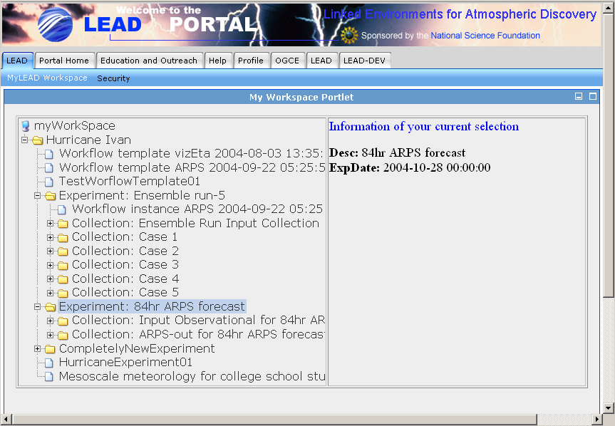

Figure 6.1. The LEAD portal. Upon logging in, the user is presented with a view of their MyLEAD workspace, which is a private metadata catalog of results from their computational experiments.

7. LEAD Workflow

The LEAD system is being developed as a sequence of prototypes of increasing sophistication that serve to test and refine research concepts, engage end users from the outset, stimulate new ideas and provide a mechanism for ensuring continuous integration among the multiple disciplines represented in LEAD. The fundamental “building blocks” of these prototypes are a series of web services (Figure 7.1) which themselves can consist of services and can be used as stand-alone applications or as part of the overall LEAD environment (see section 6). Once the full complement of services has been developed, users can combine them, via an orchestration interface, in numerous ways to create a wide array of capabilities, adding other services as necessary or creating and saving workflows of services that themselves can be combined in new workflows to solve increasingly complex problems (Figure 7.2).

Figure 7.1. Web services, the building blocks of LEAD.

Figure 7.2. By combining LEAD services using the workflow engine, users can create a wide array of capabilities for research and education. Additional services can be added by the user as needed.

7.1 Building Experimental Workflows

Interacting with the LEAD system is based upon a very comfortable concept for users: performing an experiment. The construction process involves selecting or composing a workflow and a set of input datasets and parameters. The experiment is initiated by enacting the workflow that, as noted above, typically orchestrates the interactions of a number of web services. In the simplest possible case, a workflow may request a decoder service to fetch a particular raw data set and decode it, using the result as input to a simulation service. When the simulation completes, the output is cataloged and made available to the user via a visualization tool. Services with which the workflow interacts are hosted on the LEAD Grid. Some of the application services merely stage files and start application tasks that run on compute clusters, such as those available through the TeraGrid. Other services function as brokers to provide access to compute resources by using an estimate of the computation work required and time constraints to select the resources needed to complete the task. The workflow instance is itself a web service that runs in a workflow engine hosted on the LEAD Grid. The workflow has a highly interactive relationship with the MyLEAD personal metadata catalog that is explored in more detail in a companion article (Plale et al. 2005).
As shown schematically in Figure 7.3, LEAD is evolving three distinct yet related generations of workflow technology. In Generation 1, workflows are static, i.e., all tasks to be performed, including their order of execution, data dependencies, and computational resources, must be determined prior to job launch and cannot be changed until the job concludes. In Generation 2, workflows can be modified by the user during execution, or by the workflow itself, in response to any number of conditions (e.g., loss of data, identification of new features in output or observations, availability of computing resources). Further, on-demand capabilities will become available in Generation 2, requiring sophisticated monitoring and performance estimation resources given the dynamic nature of the workflows. Generation 3 will provide the capability for meteorological tools to interact mutually with adaptive remote sensors, most notably the CASA Doppler weather radars.

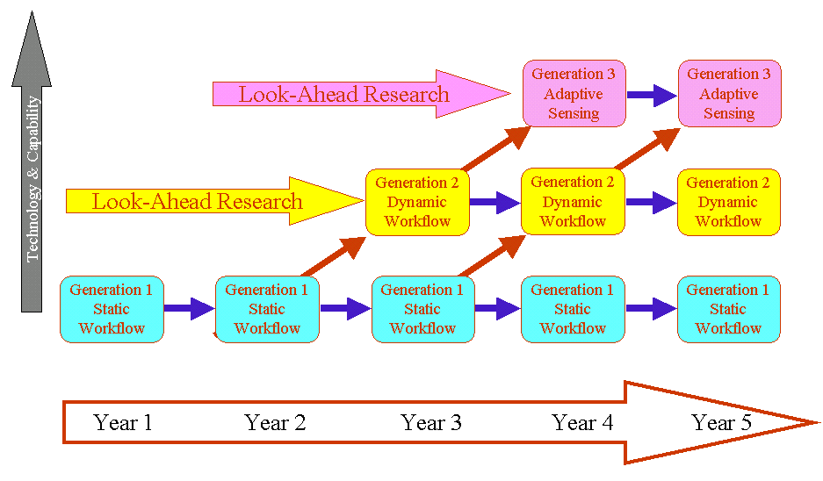

Figure 7.3. LEAD technology generations.

7.2. Workflow in a Dynamically Adaptive Environment

The adaptation requirements, in both space and time, of simulations, the potential of adaptive instrumentation, and adaptive cyberinfrastructure make LEAD workflow management unique. Traditional workflows are static patterns that coordinate fixed sets of partners through carefully orchestrated activities. Humans often are in the loop but usually at prescribed points where a specific decision or approval is required. In sharp contrast, LEAD workflows are event driven. For example, a data-mining agent may be monitoring a streaming radar data feed looking for a specific set of weather patterns. Once detected, the agent may send a notification to the workflow engine that causes a workflow to be re-activated. This is accomplished via the generation of a workflow current status message, such as “waiting for a notification”, that is stored in a database managed by the workflow engine. The workflow engine itself is a persistent web service that may manage hundreds of workflow instances concurrently. When the engine receives a message it identifies the appropriate workflow instance (to which the message is addressed) and then advances the state of that workflow through its tasks until another message becomes available. The workflow instance then is “suspended” and placed back into the database.
LEAD is building its workflows upon the Business Process Execution Language (WS-BPEL) (Andrews et al. 2003), which is a widely accepted industry standard because it is the only one that provides the relevant control constructs for modeling behavior that is dynamic in character. We have built a BPEL execution engine that works within the SOA security mechanisms defined by the LEAD testbed. Because BPEL is completely service oriented, it can query and respond to external services such as resource allocators and monitoring services. BPEL also has a well defined “exception” model that allows a workflow to change course if an unexpected condition arises. Unfortunately, BPEL is not well suited to the casual scientific user. Consequently, from the portal we are providing a “drag and drop” composition tool that will allow for an intuitive “graphical” construction of workflows which are then translated into BPEL. Deciding the best way to design such remains an open research problem.
8. The Vital Role of Monitoring
Events that cause adaptive behavior can occur at any level in the system, for instance, in the environment when a weather condition arises, in a forecast model analysis that results in directives to a local radar, at the service layer in response to inefficiencies in an ongoing workflow execution, or at the hardware and system software layer in response to excessive computational or network loads. For the system to be responsive to simultaneously occurring high priority events, it employs services to detect, sense, and monitor the environment. These detection services are distributed and gather specialized information close to the source.
Concretely, a mesocyclone detection service (Li et al. 2004) might operate on a NEXRAD Doppler radar data stream at one of the test bed sites. An instance of the algorithm also might be deployed to examine the 3-D assimilated data set generated by a particular experiment. Monitoring detection components, discussed in more detail below, can monitor network and compute resources, forecasting components, data assimilation, or the workflow itself (Plale et al. 2005).
As these examples illustrate, the complexity of the LEAD architecture’s dynamic characteristics make monitoring and understanding of application resource behavior both more critical and challenging. When reacting to crucial weather changes or changing resource availability, the LEAD system must proactively assess and detect system performance anomalies, enable recovery and ensure continued operation.
Before a workflow can begin execution, it must be mapped to a set of physical resources that can meet the expected performance and reliability guarantees. The quality of service (QoS) provided to a given workflow depends on its criticality (e.g., real-time weather constraints), the behavior of the workflow components and the changing capabilities of the underlying execution resources. In addition, the geographically distributed nature of the execution resources introduces new failure modes, and monitoring services must monitor and predict possible resource loss. Finally, the dynamic nature of LEAD workflows may lead to additional resources being requested during the lifetime of the workflow. The LEAD system must use knowledge of application needs and the current resource state, obtained from the monitoring services, to allocate new resources to the workflow. The goal of this allocation is to enable timely execution of the workflow with the desired performance and reliability guarantees.
To support real-time monitoring of distributed LEAD workflows, we are developing a new infrastructure that combines elements of (a) the Autopilot (Reed 2005) distributed performance monitoring toolkit, the SvPablo application performance toolkit (DeRose et al, 1998), the Health Application Monitoring Interface (HAPI), and a workflow annotation system that show the state of executing workflow elements.
Autopilot sensors execute as part of the monitoring services to collect performance data periodically. At each stage, the workflow engine publishes events about the progress of the workflow (e.g., workflow started, LDM started, or WRF ended). A central control service subscribes to these events to monitor the progress of the workflow. This enables correlation between collected performance data and workflow progress. This central service can be used to monitor progress during workflow execution or trigger scheduling/rescheduling decisions during the orchestration of the workflow.
In addition to workflow instrumentation via Autopilot, we are exploiting the SvPablo application instrumentation and performance tuning toolkit to capture data on the interaction of workflow components with system resources. By measuring the performance of computation intensive components such as WRF, we can both optimize component performance and improve workflow scheduling.
The performance monitoring infrastructure is complemented by a reliability monitoring toolkit. This will enable us to use reliability data to make scheduling decisions and to anticipate likely failures and take action before workflows are disrupted. The failure indicator infrastructure in LEAD is based on the Health Application Programming Interface (HAPI). HAPI is an API for discovery and use of health-related diagnostic information such as disk warnings based on the SMART protocols and hardware health, including temperature and fan status.
By combining performance and failure models, the infrastructure can guarantee continued operation of weather forecasting and respond to additional resource requests based on weather phenomena. Figure 8.1 shows an early prototype of our monitoring system, coupled to a simple workflow specification and orchestration interface.

Figure 8.1. Prototype Workflow Monitoring

9. Transforming Education Through Dynamically Adaptive Learning
What will LEAD mean to the communities of researchers, educators, and students that stand to be the principal beneficiaries of its capabilities? In order maximize its effectiveness for these groups, LEAD embraces a fully integrated strategy that engages individuals from its target user communities (education: Grades 6 – graduate level; research and operations) and facilitates an ongoing exchange of ideas among them and IT and meteorology researchers and developers. This plan assures the active participation of users in the development, design, and refinement of LEAD technologies from the outset. As new prototypes are developed, users test various features in their own productivity environments and participate in evaluation and refinement by providing feedback.
Toward this end, the education and outreach component of LEAD has established so LEAD Learning Communities (LLC). They comprise a collaborative network of teachers, researchers, and students who interact to address a variety of issues related to LEAD that are common to their particular community. The principal goal of LLCs is to enable and foster two-way interaction between LEAD developers and users so as to maximize the overall effectiveness of each new capability. Each LLC 1) integrates LEAD applications into their domain of activity, 2) develops new applications, 3) creates performance outcomes for both education and research, 4) provides feedback to LEAD developers so that user needs drive the design and development process, and 5) determines potential relevance of LEAD technologies to other related fields and initiatives.
Central to this strategy is the development of Dynamically Adaptive Learning Environments (DALE) for educators and students. In contrast to more conventional learning in which a student proceeds through a largely deterministic pathway toward understanding a particular concept, DALE places the student in an inquiry-based environment where he or she can explore new ideas by creating entirely new pathways and tools. A user enters this environment through the LEAD portal (Figure 6.1) and is able to access a suite of capabilities that can be used for data and information discovery, as well as applications and resources specific to education as refined by educators through their LLCs. Users can employ data mining that incorporates an embedded ontology service to explore various concepts, discover concept-relevant data, metadata, and other resources in real-time or in repositories resident on THREDDS servers. Further, they can create visualizations in IDV including animations generated in a background mode. Such workflows can be packaged as a learning module to be invoked by other students and educators or used as an initial state for higher-level concept mapping.
Although still an emerging concept within LEAD, DALE gives users the ability to conduct a “find” in virtual concept space where guided inquiry is directed by intelligent tutoring. Furthermore, users in various physical locations have the capability to share data, analysis and visualization tools, and other resources. This requires that security and access be tailored to the needs of the education level. For instance, a graduate student may have access to the full range of LEAD services and would be allowed to initiate a workflow targeted to his/her research. Conversely, undergraduates and high school students are more likely to have limited permissions to access LEAD capabilities as a group, except in special cases involving undergraduate research activities.
Tool and services that offer student-centered capabilities are predicted on the existence of rich, dynamic models of student understanding (Corbett, Koedinger et al 2001). Such models depict key ideas that learners should understand, common learner conceptions and misconceptions, and how these ideas change over time as student understanding becomes increasingly sophisticated (AAAS, 1993; AAAS 2001a; Sumner, Ahmad et al 2004). DALE enables this transformation in student experience and knowledge, provides a unique opportunity for just-in-time teaching and assessment, facilitates a natural connection between research and education, allows for new means for students to demonstrate understanding of mesoscale processes, and is scalable and extensible to the whole of geosciences.
10. Acknowledgments
LEAD is a Large Information Technology Research (ITR) Grant funded by the National Science Foundation under the following Cooperative Agreements. ATM-0331594 (University of Oklahoma), ATM-0331591 (Colorado State University), ATM-0331574 (Millersville University), ATM-0331480 (Indiana University), ATM-0331579 (University of Alabama in Huntsville), ATM03-31586 (Howard University), ATM-0331587 (University Corporation for Atmospheric Research), and ATM-0331578 (University of Illinois at Urbana-Champaign, with a sub-contract to the University of North Carolina).
11. References
AAAS, 1993: Benchmarks for science literacy, New York – Project 2061. American Association for the Advancement of Science, Oxford University Press.

AAAS, 2001a: Atlas of Science Literacy, Project 2061. American Association for the Advancement of Science, and the National Science Teachers Association.

Andrews, T., F. Curbera, H. Dholakia, Y. Goland, J. Klein, F. Leymann, K. Liu, D. Roller, D. Smith, S. Thatte, I. Trickovic, and S. Weerawarana, 2003: Business Process Execution Language for Web Services, v1.1, IBM Developers Library, May.

Antonioletti, M., M. Atkinson, R. Baxter, A. Borley, N. P. Chue Hong, B. Collins, N. Hardman. A. C. Hume, Alan Knox, M. Jackson, A. Krause, S. Laws, J. Magowan, N. W. Paton, D. Pearson, T. Sugden, P. Watson and M. Westhead, 2005: Design and implementation of Grid database services in OGSA-DAI, Concurrency and Computation: Practice and Experience, 17, No. 2-4, Feb – Apr, pp. 357--376

Atger, F., 2003: Spatial and interannual variability of the reliability of ensemble-based probabilistic forecasts: Consequences for calibration. Mon. Wea. Rev., 131, 1509–1523.

Box, D., L. Cabrera, C. Critchley, F. Curbera, D. Ferguson, A. Geller, S. Graham, D. Hull, G. Kakivaya, A. Lewis, B. Lovering, M. Mihic, P. Niblett, D. Orchard, J. Saiyed, S. Samdarshi, J. Schlimmer, I. Sedukhin, J. Shewchuk, B. Smith, S. Weerawarana and D. Wortendyke, 2004: Web Services Eventing (WS-Eventing), http://ftpna2.bea.com/pub/downloads/WS-Eventing.pdf, August.

Brewster K., 1996: Application of a Bratseth analysis scheme including Doppler radar data. Preprints, 15th Conf. Wea. Anal. Forecasting., Amer. Meteor. Soc., Norfolk, VA, 92–95.

Corbett, A. T., K. R. Koedinger and W. H. Hadley, 2001. Cognitive tutor: from the research classroom to all classrooms. Technology Enhanced Learning: Opportunities for Change, P.S. Goodman, Ed. Mahwah, NJ, Lawrence Erlbaum Assoc, 235-263.

Davis, E.R. and J. Caron, 2002: THREDDS: A geophysical data/metadata framework. Preprints, 18th Int. Conf. on Interactive Information Processing Systems (IIPS) for Meteorology, Oceanography, and Hydrology, 13-17 January, Amer. Meteor. Soc., Orlando, Florida, 52-53.

DeRose, L., Y Zhang, and D. A. Reed, SvPablo, 1998: A Multi-Language Performance Analysis System. 10th International Conference on Computer Performance Evaluation - Modeling Techniques and Tools - Performance Tools' 98, pp .352 - 355, Palma de Mallorca, Spain, September 1998.

Dietachmayer, G. and K. Droegemeier, 1992: Application of continuous dynamic grid adaption techniques to meteorological modeling, Part I: Basic formulation and accuracy. Mon. Wea. Rev., 120, 1675-1706.

Fleming, R. J., 1971a: On stochastic dynamic prediction I: The energetics of uncertainty and the question of closure. Mon. Wea. Rev., 99, 851-872.

Fleming, R. J., 1971b: On stochastic dynamic prediction II: Predictability and utility. Mon. Wea. Rev., 99, 927-938.

Foster, I. and C. Kesselman, 1997: Globus: A Metacomputing Infrastructure Toolkit, International Journal of Supercomputer Applications,11, No. 2, pp. 115-128.

Kalnay, E., 2003: Atmospheric Modeling, Data Assimilation and Predictability. Cambridge Press, 341pp.

Kong, F., K. K. Droegemeier, and N. L. Levit, 2005: Multiple resolution ensemble forecast of an observed tornadic thunderstorm system. Part I: Comparison of coarse and fine grid experiments. Accepted for Mon. Wea. Rev.

Lee, S., B. Plale, S. Jensen, Y. Sun, 2005: Structure, sharing, and preservation of scientific experiment data, To appear IEEE 3rd International Workshop on Challenges of Large Applications in Distributed Environments (CLADE), July.

Li, X., Ramachandran, R., Rushing, J., and S. Graves, 2004: Mining NEXRAD Radar Data: An Investigative Study. Preprints, 20th Int. Conf. on Interactive Information Processing Systems (IIPS) for Meteorology, Oceanography, and Hydrology, 12-15 January, Amer. Meteor. Soc., Seattle, WA.

McLaughlin, D.J., V. Chandrasekar, K.K. Droegemeier, and S.J. Frasier, 2005: Distributed collaborative adaptive sensing (DCAS) for improved detection, understanding, and prediction of atmospheric hazards. Preprints, 9th Symp. On Integrated Obs. and Assimilation Systems for the Atmos., Oceans, and Land Surface, 9-13 January, San Diego, CA, Amer. Meteor. Soc.

Michalakes, J., S. Chen, J. Dudhia, L. Hart, J. Klemp, J. Middlecoff, and W. Skamarock, 2000: Development of a next-generation regional weather research and forecast model. Proceedings of the Ninth ECMWF Workshop on the use of Parallel Processors in Meteorology, Reading, U.K., November 13-16, 2000. Argonne National Laboratory preprint ANL/MCS-P868-0101.

Morss, R.E., K.A. Emanuel and C. Snyder, 2001: Idealized adaptive observation strategies for improving numerical weather prediction. J. Atmos. Sci., 58, 210-232.

Murray, D., J. McWhirter, S. Wier, and S. Emmerson, 2003: The Integrated Data Viewer—a web-enabled application for scientific analysis and visualization. Preprints, 19th Conf. On Integrated Information and Processing, 8-13 February, Long Beach, CA, Amer. Meteor. Soc.

NCDC, 2000: National Climatic Data Center March 2000 Storm Data, 42, No.3, 172pp.

Oasis Consortium, 2005: http://www.oasis-open.org/home/index.php, April.

Open Grid Computing Environment, 2005: http://www.ogce.org/index.php.

Pielke, R.A. and R. Carbone, 2002: Weather impacts, forecasts, and policy. Bull. Amer. Meteor. Soc., 83, 393-403.

Plale, B., J. Alameda, R. Wilhelmson, D. Gannon, S. Hampton, A. Rossi, and K.K. Droegemeier, 2004: User-oriented active management of scientific data with my LEAD. IEEE Internet Computing, 9, 27-34.

Plale, B., D. Gannon, Y. Huang, G. Kandaswamy, S. Pallickara, and A. Slominski, 2005: Cooperating Services for Managing Data Driven Computational Experimentation. Submitted to Computing in Science and Engineering.

Plale, B., D. Gannon, D. Reed, S. Graves, K. Droegemeier, B. Wilhelmson, M. Ramamurthy, Towards Dynamically Adaptive Weather Analysis and Forecasting in LEAD, 2005, To appear ICCS workshop on Dynamic Data Driven Applications, Atlanta, Georgia, May 2005.

Ramachandran, R., S. Graves, H. Conover, and K. Moe, 2004: Earth Science Markup Language (ESML): a solution for scientific data-application interoperability problem. Computers & Geosciences, 30, 117-124.

Reed, D. A. and C Mendes, 2005: Intelligent Monitoring for Adaptation in Grid Applications. Proceedings of the IEEE, 93, Issue 2, 426-435.

Rushing, J., R. Ramachandran, U. Nair, S. Graves, R. Welch, and A. Lin, 2005: ADaM: A Data Mining Toolkit for Scientists and Engineers. In press for Computers & Geosciences.

Rew, R. K. and G. Davis, 1990: Distributed data capture and processing in a local area network. Preprints, 6th Int. Conf. on Interactive Information and Processing Systems for Meteorology, Oceanography and Hydrology, February, Anaheim, CA, Amer. Meteor. Soc., 69-72.

Skamarock, W. C. and J. B. Klemp, 1993: Adaptive grid refinement for two-dimensional and three-dimensional nonhydrostatic atmospheric flow. Mon. Wea. Rev., 121, 788-804.

Sumner, T., F. Ahmad, S. Bhushan, Q. Gu, F. Molina, S. Willard, M. Wright, L. Davis, and G. Janee, 2004: Linking learning goals and educational resources through interactive concept map visualizations. International Journal of Digital Libraries, 5, 18-24.

Unidata Program Center (UPC), 2002: The Internet Data Distribution System (IDD). http://my.unidata.ucar.edu/content/publications/factsheets/idd.html.

Unidata Program Center (UPC), 2005: LDM. http://my.unidata.ucar.edu/content/software /ldm/index.html.

Vazhkudai, S. S. Tuecke, and I. Foster, 2001: Replica Selection in the Globus Data Grid, IEEE/ACM International Conference on Cluster Computing and the Grid (CCGRID), IEEE Computer Society Press, pp. 106-113.

World Wide Web Consortium, 2005: http://www.w3c.org, April.

Xue, M., D.-H. Wang, J.-D. Gao, K. Brewster, and K. K. Droegemeier, 2003: The Advanced Regional Prediction System (ARPS): Storm-scale numerical weather prediction and data assimilation. Meteor. and Atmos. Physics, 82, 139-170.

Advanced Regional Prediction System (ARPS), developed by the Center for Analysis and Prediction of Storms at the University of Oklahoma.
Note that techniques exist for “calibrating” ensemble forecasts against observational statistics (e.g., Atger 2003).

