The Socioeconomic and Environmental Benefits of a Weather, Climate and Earth-System Prediction Initiative for the 21st Century

Melvyn Shapiro, Jagadish Shukla², Brian Hoskins³, John Church⁴, Kevin Trenberth⁵, Michel Béland⁶, Guy Brasseur⁷, Mike Wallace⁸, Gordon McBean⁹, Jim Caughey¹⁰, David Rogers¹¹, Gilbert Brunet¹², Leonard Barrie¹³, David Parsons¹⁴, David Burridge¹⁵, Tetsuo Nakazawa¹⁶, Martin Miller¹⁷, Philippe Bougeault¹⁸, Richard Anthes¹⁹, Zoltan Toth²⁰, Jerry Meehl²¹, Randall Dole²², Mitch Moncrief²³ , Hervé Le Treut²⁴, Alberto Troccoli²⁵, Tim Palmer²⁶, Jochem Marotzke²⁷, and John Mitchell²⁸

Capsule: An international Weather, Climate and Earth-System Observations and Prediction Initiative to increase the use and value of weather, climate and environmental information available to decision makers.

Abstract: This article is intended to inform policy makers, national academies of science, users and providers of weather, climate and environmental information of the necessity for establishing a Weather, Climate and Earth-System Observations and Prediction Initiative to increase the capacity of disaster-risk-reduction managers and environmental policy makers to make decisions to minimize and adapt to the socioeconomic and environmental vulnerabilities arising from high-impact weather and climate. This endeavor is as ambitious as the Apollo Moon Project, International Space Station, Genome Project and Hubble Telescope with a high socioeconomic and environmental benefits-to-cost ratio. It will enhance the use and benefits of the observation, prediction and warning-system components of the Global Earth Observation System of Systems (GEOSS). It will accelerate advances in weather, climate and Earth-system prediction and the use of this information by global societies. Delivering the benefits from this endeavor will require building upon the Group on Earth Observations (GEO) and the World Meteorological Organization (WMO), to coordinate the effort across the weather, climate, Earth-system, natural-hazards and socioeconomic disciplines. It will require investments in: i) maintaining existing, and developing new observational capabilities; ii) high-performance computing capacity; iii) high-speed/broadband telecommunication linking a world-wide network of research and operational-forecast centers, and warning and planning systems; iv) underpinning science and technology research, and education projects to enhance knowledge, awareness and utilization of weather, climate, environmental and socioeconomic information; iv) infrastructure to coordinate and transition academic, government-agency, private-corporation and user achievements into operational products and services.

1. Prologue

This document was prepared by scientists from the World Meteorological Organization (WMO)-World Weather Research Program (WWRP), World Climate Research Program (WCRP), International Geosphere-Biosphere Program (IGBP) and the natural-hazards and socioeconomic communities. It was introduced at the Ministerial and Plenary Sessions of the Group on Observations (GEO) Summit, convened in December 2007, Cape Town South Africa; Shapiro et al. 2007. It is intended to inform policy makers, national academies of science and users of weather, climate and environmental information of the necessity for establishing a Weather, Climate and Earth-System Observations and Prediction Initiative. This endeavor will increase the capacity of disaster-risk-reduction managers and environmental policy makers to make decisions to minimize and adapt to the increasing societal, economic and environmental vulnerabilities arising from high-impact weather within an ever-changing climate. It is as ambitious as the Apollo Moon Project, International Space Station, Genome Project and Hubble Telescope with a high socioeconomic and environmental benefits-to-cost ratio. It will enhance the use and benefits of the observations, prediction and early-warning system components of the Global Earth Observation System of Systems (GEOSS). It will accelerate advances in weather, climate and Earth-system prediction and the use of this information by global societies. Delivering the benefits from this endeavor will require building upon the World Meteorological Organization (WMO) and Group on Earth Observations (GEO) as an international framework to coordinate the Project across the weather, climate, Earth-system, natural-hazards and socioeconomic disciplines.

2. Rationale

The vulnerability of modern society, economies, and the environment to high-impact weather and climate is demonstrated by the socioeconomic, environmental and health impacts of extreme weather and climate events, such as: i) the destructive flooding rains over India, China, England, and the United States and the simultaneous southeastern Europe severe heat wave and drought during the summer of 2007; ii) the devastation of New Orleans by Hurricane Katrina in 2005; iii) the deadly European heat wave of August 2003 and associated life-threatening air quality; iv) the recent multi-decadal African drought that ravaged the semi-arid regions of the Sahel (Fig. 1). Effective mitigation of the impacts of, and adaptation to, such events requires accurate prediction of the likelihood of changing weather and climate at global, regional and local scales. Such capabilities will enhance the capacity of disaster-risk-reduction managers, infra-structure planners, and socioeconomic and environmental policy makers to make decisions that reduce human, economic and environmental losses, as well as maximize economic opportunities, e.g. optimal trade routs; energy allocation; tourism; leisure activities, crop selection and harvesting, that may arise from high-impact weather and climate. Notably, hazardous weather and climate affects both developing and developed worlds. Improved weather/climate information, along with an improved utilization of this information is used is paramount worldwide.

We stand at the threshold of providing and responding to major advances in observations, analysis and prediction of high-impact weather and climate events, and the complex interaction between the physical-biological-chemical Earth system and global societies (NRC, 2007;2008). This opportunity stems from the notable advances in monitoring and predicting short-term weather hazards, and climate variability and change, and the utilization of this information by disaster-risk-reduction managers and environmental policy makers. For example: i) short-term regional forecasts (hours to days) prepared on spatial scales of a few

Fig. 1: The socioeconomic and environmental impacts of hazardous weather and climate. Upper left: Brush fire in Macedonia during the south-eastern European summer heat wave of 2007. Upper right: The town of Upton-upon-Severn in Worcestershire, England was surrounded by water during the devastating flooding of July 2007. Lower left: Father and son in flood ravaged Bangladesh, 2007. Lower right: An Ethiopian goat herder leads his livestock through the dust in the desert where severe drought in East Africa has forced overgrazing, which destabilizes the soil.

kilometers, are currently capable of predicting the occurrence of flooding rainstorms, air-quality emergencies, coastal storm surges, severe wind events, hurricane track and land fall, with reasonable skill; ii) global-weather prediction has advanced to the point that national weather centers routinely provide useful forecasts with a 5-day forecast accuracy comparable to the 2-day forecasts of 25 years ago, including ensemble prediction systems that provide probability estimates of their expected level of skill for a week or more; iii) climate projections of global temperature and precipitation distributions provided the scientific underpinning for international treaties to modify human activities that contribute to the emission of carbon dioxide and other greenhouse gases; iv) risk assessment models have become increasingly important in evaluating the socioeconomic and environmental benefits and outcomes of different decisions. These accomplishments represent some of the most significant scientific, technological and societal achievements of the 20th century.

Building on the advances over the past decades, we foresee the potential for further scientific breakthroughs that will enable governments to more effectively respond to the hazards of extreme weather and climate and to realize higher levels of societal, economic and environmental benefit (NRC, 2007). The high priority of expanding our weather, climate and Earth-system observation, analysis, and prediction capability is justified by both evidence of the increasing incidence of weather and climate extremes, as reported by the Intergovernmental Panel for Climate Change (IPCC, 2007) and by the ever increasing vulnerability of society, economies and the environment to high-impact weather, and climate variability and change. Over 75 percent of the natural disasters around the world are triggered directly or indirectly by weather and climate events.

The distinction between weather, climate and Earth-system prediction, and the link with hazard risk-reduction and adaptation, is transitioning into a seamless suite of models applicable over all relevant decision-making spatial and temporal scales. Here the concept of seamless is 4-dimensional, being: 1) seamless in spatial dimension extending from, e.g., highly localized cloud systems to global

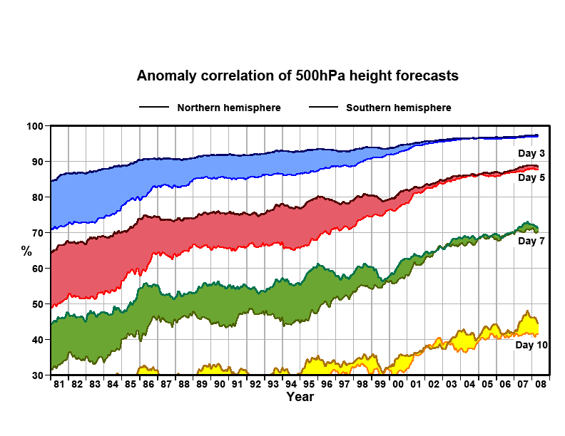

Fig. 2: Evolution of forecast skill for the northern and southern hemispheres: 1980-2008. Anomaly correlation coefficients of 3, 5,7 and 10-day ECMWF 500-mb height forecasts for the extratropical northern and southern hemispheres, plotted in the form of running means for the period of January 1980-August 2004. Shading shows differences in scores between hemispheres at the forecast ranges indicated, courtesy of Martin Miller (ECMWF)

circulations and their two-way interactive feedbacks; 2) seamless across time, spanning minutes to centuries, e.g., micro/meso-scale life cycles to long-term climate variability and change; 3) seamless across scientific disciplines, e.g., weather, climate, Earth-system, and socioeconomics; 4) seamless across academic institutions, government research and service agencies, private-enterprise providers, and hazard risk-reduction and adaptation agencies and organizations. Within this paradigm shift, socioeconomic and environmental demands are an integral component in the design and implementation of a new generation of science-based global to regional early-warning and planning systems that will enable major advances in minimizing vulnerability, and adapting to daily through multi-decadal hazards of high-impact weather, and climate variability and change. In the same way that the atmosphere encompasses the Earth, the expertise to exploit further advances in observations, monitoring and prediction of the physical-biological-chemical Earth system and its interaction with the global socioeconomic system resides across many nations, international organizations and diverse scientific disciplines. Advancing the skill of weather, climate and Earth-system prediction to minimize vulnerabilities and adapt to the societal, economic and environmental risks of high-impact weather and climate is a global enterprise for the 21st century.

2. Recent Progress

Global societies of today derive substantial benefits from weather and climate observations, analyses and predictions. These benefits include: i) early warning systems that assess risk and reduce vulnerability arising from weather, climate, and air-quality hazards; ii) weather, climate, and complex Earth-system prediction systems tailored for the specific needs of societal, economic, and environmentally sensitive sectors, e.g., energy, water-resource management, health, air and water quality, transportation; agriculture, fisheries, leisure industries, ecosystems, biodiversity and national security; iii) quantitative measures of the probability of occurrence and potential severity of a given socioeconomic or environmental outcome. It is recognized that mitigation and adaptation strategies require predictions of the probability and uncertainty of occurrence of extreme events on both weather and climate time scales. The occurrence of extreme weather and climate events may be infrequent, but the consequences can be catastrophic to those societies and ecosystems that are affected.

Recent progress in the atmospheric, oceanographic, Earth-system, and socioeconomic sciences, observations, computer technology and global communication systems offers the opportunity to accelerate further advances in the accuracy and use of weather, climate prediction information. These advances include: i) greatly expanded capability to observe the atmosphere, oceans, land and ice surface, including their bio-geochemical properties; ii) increasingly accurate weather, climate and Earth-system prediction models, aided by improvements in numerical methods, representations of physical processes, probabilistic (ensemble) prediction systems and the continuous exponential increase in the capacity of high-performance computers; iii) advanced knowledge of the theoretical and practical limits of atmospheric and oceanic predictability, including the influence of climate variability and change on high-impact weather events; iv) the societal, economic and environmental utilization of weather, climate and Earth-system information to assess, mitigate and adapt to natural and human-induced environmental disasters.

3. Core Elements of an International Weather, Climate, and Earth-system Prediction Initiative

The core elements of an international Weather, Climate and Earth-system Prediction Initiative will build upon the above achievements and will include:

High-resolution observations and models – High-resolution observations and models of the atmosphere, ocean, land, encompassing dynamical, physical and biogeochemical processes that: i) monitor and predict the seamless interaction among weather, climate, the Earth system and global socioeconomics; ii) resolve the detailed properties of the atmosphere, oceans, land, ice, atmospheric composition, and bio-geochemistry with computational resolution consistent with the spatial scale of the applications, Fig. 3; iii) address daily, seasonal, inter-annual and multi-decadal prediction for short-term societal functions and long-term policy decisions; iv) provide scientifically-based assessments of predicted changes and the actions required to mitigate their impact, including assessments of the potential consequences of emerging geo-engineering intervention hypotheses designed to modulate climate variability and change and its associated high-impact weather.

High-resolution global and regional data-assimilation and analysis systems – that enhance the optimum use and value of the full spatial and temporal resolution of observations from space, land/ice surfaces and oceans. This requires the development of advanced data-assimilation systems which incorporate weather, climate and Earth-system prediction models as an integral component in the analysis of the observations and so provide a sensor-integrated synergy for the monitoring, prediction and forecast verification of weather, climate, and biochemical properties of the Earth system.

Advanced High-Performance Computing (HPC) capabilities –to enable the implementation of: i) next- generation weather, climate, and Earth system monitoring, assessment, data-assimilation, and prediction systems; ii) ensemble-prediction systems that include many possible predictions and projections, thereby allowing probabilities of high-impact events to be deduced and performed with high-resolution models for weather, climate variability, and Earth-system prediction; iii) long-term (multi-decadal) integrations of climate models for climate-variability prediction and climate-change projections that include a high degree

Fig. 3: An illustration of the limitation of course-resolution, multi-decadal climate-projection models to resolve regional high-impact weather events routinely predicted by today’s 14-day higher-resolution operational forecast systems. Left panel, global cloud distribution in a 320-km resolution climate simulation experiment. Right panel, same as left panel, but for a 20-km resolution simulation with the same model, comparable in resolution to the most advanced operational weather forecast models of today. The proposed Project will provide high-resolution climate models that capture the properties of regional high-impact weather events, such as tropical cyclones; heat waves; sand and dust storms, associated within multi-decadal climate projections of climate variability and change (Courtesy of Takeshi Enomoto, Earth Simulator Center/JAMTEC).

of Earth-system complexity and interaction with socioeconomic models that account for the response of society to the projections. It is envisioned that these three elements (i-iii) will require access to dedicated HPC facilities with sustained speeds well beyond that of the most advanced computers of today (achievable within 10-20 years), each supported by a critical mass of scientists and technicians. Each facility could be supported by a cluster of countries with common interest in high-resolution prediction of weather, and climate variations and change. Advanced data processing, visualization methods, and a user-friendly, high-speed and high-bandwidth, common-data format, and an integrated data-distribution system that allows access to most information in near real time, are required to fully realize the research and operational benefits of the high-resolution analyses and predictions that will be generated by high-performance computing.

Data and forecast-information-system archive – Establishment of an internationally-coordinated weather, climate, Earth-system and socioeconomic data and forecast information-system archive that: i) provides universal access to observational, experimental and operational global data bases, commensurate with the highest resolution achievable, given near-term observational and computational constraints; ii) facilitates advanced analysis and visualization representations of observed and predicted weather, climate Earth-system events and their impacts.

Underpinning research – To improve the performance and application of models, thus providing the basis for more skilful predictions with known confidence through advanced knowledge of weather, climate and Earth-system processes and their past, present and future fluctuations and change. As an example, one of the foremost research challenges, with major implications for forecast capability, is to improve the ability of weather and climate models to initiate and maintain the organisation of precipitating cloud systems in the tropics on space-scales of tens-to-thousands of kilometres and time-scales of hours to weeks; Fig. 4. Underpinning research will also include: i) the diagnosis of observed weather, climate and Earth system phenomena using routinely analysed observations and special observations from multidisciplinary field campaigns; ii) performance and analysis of detailed numerical simulations of particular weather, climate and Earth system processes; iii) development and application of advanced data-assimilation methods; iv) performance assessments of weather, climate and Earth system simulations and predictions; v) efforts that assess and advance the socioeconomic use of advanced observations and prediction systems for weather, climate and the Earth-system By making socioeconomic decision tools an integral component of the system.

Decision support information – The production of weather, climate and Earth-system information is crucial in assisting decision-making processes for risk reduction and adaptation to potentially more severe weather and climate events, mitigation policies, and sustainable development. This requires exploiting advances in: i) forecasts of short-term weather hazards; ii) observations and analyses of changes that have occurred; iii) predictions of climate variability and change at the regional and local scale and of their inherent uncertainties, including predictions of the climatology of extreme events, e.g., tropical cyclones, winter storms, regional floods, droughts, and dangerous air quality; iv) consequence assessment tools, which can utilize environmental, economic and social information to predict societal and environmental outcomes. However, in order for weather, climate and earth-system information to have an impact on socioeconomic activities, several elements must be attained several forecast elements: i) content: relevance of product information to the users, ii) distribution: product dissemination on spatial and temporal scales sufficient for action, iii) communication: product formats that users can comprehend and interpret, iv) recognition: recognition by users that the information has value, and v) response: actions taken by users in response to the information. These elements are links along a chain of action. If any one link is broken, then the impact and the value of the weather/climate information will be diminished. Socioeconomic research and its applications can identify weaknesses in these links and lead to the development of new methods for enhancing the use and value of weather and climate information.

4. Required Investments

Delivering the benefits from this ambitious endeavor will require building upon GEO as an international organizational framework to coordinate the proposed Weather, Climate and Earth-system Initiative across the weather, climate, Earth-system, natural hazards and socioeconomic disciplines, including the infrastructure required to support the elements described in Section 3. The effort will require:

- Maintaining and enhancing surface and upper-air global observing networks and the development and implementation of a new generation of in-situ and space-based observing systems to meet the increasing observational demands of today’s and future generations of prediction and early-warning systems.

- High-performance computing facilities with sustained speeds of more than many thousands of times the most advanced computers of today (achievable within 10-20 years), including advanced data-processing, information-distribution and visualization systems; each facility staffed with a critical mass of scientists and linked to a global network of research, forecast and early-warning centers.

- Education, science and technology transfer projects to enhance awareness and utilization of weather, climate, environmental and socioeconomic information.

- Infrastructure to transition Project achievements into operational products and services.

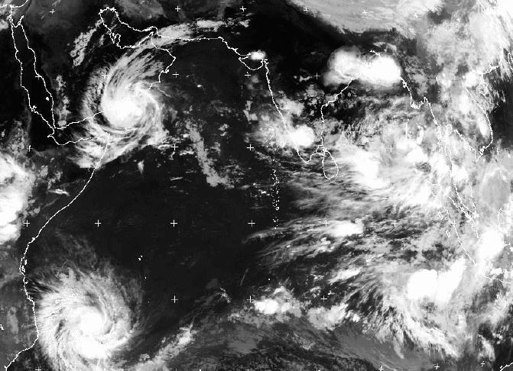
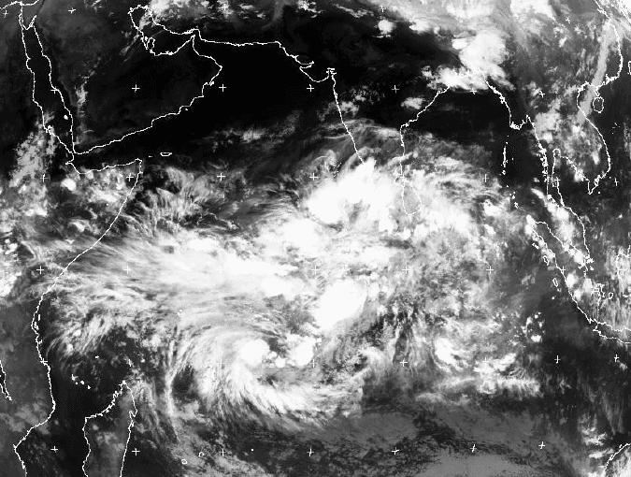

Fig. 4: Tropical convective organisation associated with a Madden-Julian Oscillation (MJO) over the Indian Ocean on 2 May 2002 (left panel). By 9 may 2002 (right pannel), the MJO propagated eastwards over Indonesia, spawning twin tropical cyclones in its wake, leading to flooding rains and 50 ms-1 winds over northern Madigascar, and heavy precipitation over Yemen. The twin tropical cyclones illustrate high-impact organised weather events directly associated with large-scale convective organisation and equatorial waves; Moncrief et al. 2007.

5. The Way Forward

The proposed Weather, Climate and Earth-System Prediction will provide the capacity to realize the full benefits from the observational, modeling, prediction and early-warning system components of GEOSS and to accelerate major advances in weather and climate prediction and their socioeconomic and environmental applications. It will require unprecedented international collaboration and good will, but the global scope of the problem makes this inescapable, as no single nation possesses the scientific capacity and infrastructure to meet the challenges set forth in this document. As nations, we have collaborated in the advancement of weather forecasting, climate prediction and global-observing systems, emergency preparedness and response. As the Group on Earth Observations, we must now extend this collaboration to embrace the Earth-system and the socioeconomic and environmental applications of our science. It is a task that must be undertaken.

6. References

NRC, 2007: Earth Science and Applications from Space-National Imperatives for the next decade and beyond. National Academies Press, Washington, D.C., 428 pp.

NRC, 2008: Earth Observations from Space-The first 50 years of scientific achievements. National Academies Press, Washington, D.C., 129 pp.

Joint Steering Committee, WMO-World Weather Research Programme (WWRP) at the National Oceanographic and Atmospheric Administration (NOAA) Office of Weather and Air Quality, USA; ²Professor, George Mason University (GMU), and President, Institute of Global Environment and Society (IGES), USA; ³Head, Dynamical Processes Group, Dept. of Meteorology, Univ. of Reading, UK; ⁴Chair, Joint Science Committee of World Climate Research Programme (WCRP) at CSIRO, Australia; ⁵Chair, WCRP Observations and Assimilation Panel at the National Center for atmospheric Research (NCAR), USA; ⁶President, WMO Commission on Atmospheric Sciences (CAS) at Environment Canada's Atmospheric Science and Technology Directorate, Canada; ⁷Director, Earth and Sun Systems Laboratory and Associate Director of NCAR, USA; ⁸Professor, Dept. of Meteorology, Univ. of Washington, USA; ⁹Professor, Institute for Catastrophic Loss Reduction at University of Western Ontario, Canada; ¹⁰Scientific Officer, THe Observing-system Research and Predictability Experiment (WWRP-THORPEX), Geneva; ¹¹Director, Health and Climate Foundation, Geneva; ¹²Chair, WMO-WWRP Joint Steering Committee and Research Director of Environment, Canada; ¹³Director, WMO-WWRP, Geneva; ¹⁴Chief, WMO-WWRP, Geneva; ¹⁵Chair, WMO-THORPEX International Core Steering Committee, Geneva; ¹⁶Chair, Asian Regional Committee for THORPEX, Meteorological Research Institute, Japan Meteorological Agency, Japan; ¹⁷Chair, WMO-CAS/WCRP Working Group on Numerical Experimentation (WGNE) at ECMWF, UK ¹⁸Head of Research, ECMWF, UK; ¹⁹President of the University Corporation for Atmospheric Research, USA; ²⁰NOAA/NCEP Environmental Modeling Center, USA; ²¹NCAR, USA; ²²NOAA Earth System Research Laboratory, USA; ²³NCAR,USA; ²⁴Directeur du Laboratoire de Météorologie Dynamique, France; ²⁵ECMWF/Euro-Mediterranean Centre for Climate Change (CMCC), Italy; ²⁶Head Probability Forecasting and Diagnostics Division, ECMWF, UK; ²⁷, Director, Max Planck Institute for Meteorology, DE; ²⁸Met. Office, UK.
The Earth-system encompasses the atmosphere and its chemical composition, the oceans, land/sea-ice and other cryosphere components; the land-surface, including surface hydrology and wetlands, lakes and human activities. On short-time scales, it includes phenomena that result from the interaction between one or more components, such as ocean waves and storm surges. On longer time scales (e.g., climate), the terrestrial and ocean ecosystems, including the carbon and nitrogen cycles and slowly varying cryosphere components (e.g., the large continental ice sheets and permafrost) would also be considered to be part of the Earth-system.

