Retrospective of LEAD Lab at the Unidata Workshop

DRAFT

August 25, 2006
Tom Baltzer, Anne Wilson, Jay Alameda, Al Rossi, Rich Clark

Introduction and Workshop Goals

During the week of July 10, 2006 Unidata held its triannual User's Workshop. The theme of this year's workshop was "Expanding the Use of Models as Educational Tools in the Atmospheric & Related Sciences" (See http://www.unidata.ucar.edu/community/2006workshop/ for more information.) Workshop organizers and LEAD team members saw this as an opportunity to unveil LEAD to and receive feedback from a self-selected group of Unidata community members that are particularly interested in being able to run forecast models. Thus it was decided that most of one day of the workshop, July 13, would be devoted to LEAD. The stated goals of the LEAD Lab day at the workshop were to introduce LEAD concepts and software to the users and to receive feedback from them, and to describe the education initiatives spawned by LEAD. In addition, the LEAD development team had the goal of performing its first or second end-to-end large-scale testing.

For the purposes of the LEAD Lab at the workshop, LEAD developers targeted a goal of allowing two sets of 25 users to simultaneously launch a high resolution, steered WRF forecast in which where users could select the forecast start time, grid spacing, and spatial domain location. The three options provided were a 5km and 20km horizontal grid spacing for a 600km by 600km domain and a 20km horizontal grid spacing for a CONUS (277km X 176km) domain. For model initialization users could select between the 40km NAM or a 10km spatial resolution ADAS assimilation, while boundary conditions were limited to 40km NAM forecasts.

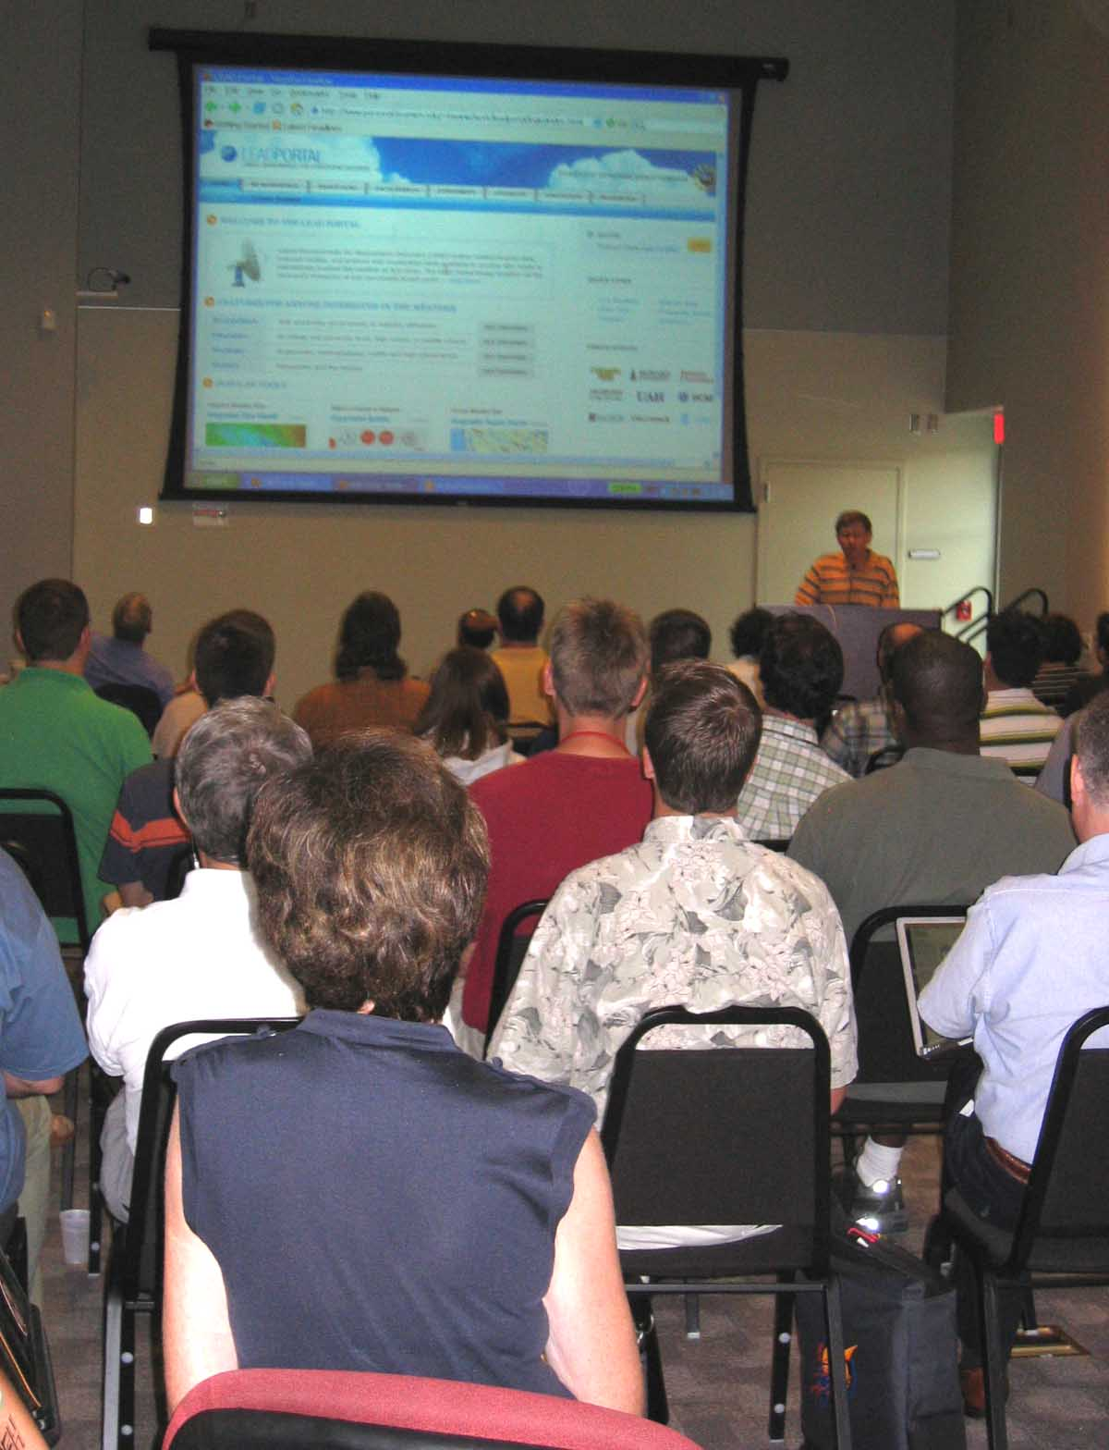

Figure X.1: Workshop participants get a tour of the LEAD Portal

Overview of the Workshop Systems

LEAD has presented two orchestration systems. One is the GPEL based workflow execution system with a portal interface primarily developed at Indiana University, referred to as the “Experiment Builder”. The other is a desktop client-based system based on the Ensemble Broker code developed at NCSA, called “Siege”. Workshop organizers demonstrated both systems at the workshop.

Both systems used (and are currently using) TeraGrid resources housed at NCSA. The Experiment Builder used a supercomputing cluster named Mercury while the Siege system used a similar cluster named Tungsten. Note that the choice of resources for each group was based on the simple fact that one group was able to get ADAS and WRF to work on Mercury, while the second group was able to get WRF-SI and WRF to work on Tungsten – porting and code validation continues to be very significant in resource choice.

Also, both systems relied on data acquired via the Unidata Internet Data Distribution (IDD) network, stored on the Unidata LEAD test bed, and cataloged and accessed via the Unidata THREDDS Data Server (TDS). (See the Tools section of this report for more information on these tools.) Also, both systems saved their results to this same TDS, and both systems used the Unidata Integrated Data Viewer (IDV) to visualize the NAM data input and the WRF model output.

Making these orchestrations work required a huge integration effort that involved TeraGrid supercomputing resources at NCSA, plus hardware at Indiana University, and the Unidata Program Center. Regarding software, the Experiment Builder required integration of the front end portal frameworks with a host of portlets with the myLEAD metadata cataloging system (with myLEAD agent in the front interacting with the myLEAD server built on top of OGSA-DAI), GPEL workflow engine, Generic Factory Service, Transient Application Services, Resource Catalog, Geographic Region Search Tool (Geo-GUI), Query Service, WS-Messenger, Host Selection Broker, Xbaya Workflow Composer, and Dynamic Service Creator.

Siege integration involved integrating the Siege desktop client with NCSA’s “troll” family of services, which includes the ensemble broker, the execution service, the host information service, the notification service, and the elf/ogrescript local execution engine, all working in concert with WRF-SI, WRF, and TDS. Through the multi-month integration effort, a number of things were accomplished:
- integration of transport-level web service security (derived from globus gsi security by NCSA’s Security Research and Development Group (Von Welch, Terry Fleury, Kevin Pricer)
- development of a custom Siege plug-in which presented a wizard interface to workshop participants, complete with event replay
- Integration of IDV to allow computational domain selection for the modeling (within the CONUS dataset selected from TDS), as well as visualization of model results
- development of an administration tool, which allowed Siege administrators to dynamically monitor use of the ensemble broker by workshop participants, as well as progress of the workflows launched by the participants
- integration of a Java Message Service (JMS) implementation (ActiveMQ), to allow for unified notification and logging and metadata throughout the distributed system

Both efforts relied on Common Teragrid Software Stack (GridFTP and GRAM, primarily), the Unidata IDV, the Unidata IDD, the Unidata TDS, ADAS, WRFSI, WRF applications, and possibly others.

There were 50 workshop machines available for use. Because each user would be launching two jobs (one from each orchestration system), LEAD Lab organizers planned two separate sessions in order to distribute the computational load. Thus the schedule for the day included two separate morning sessions, each with half the workshop participants, during which users configured their accounts, configured their forecasts, and launched them. Intermingled with these morning sessions was a session on activities being conducted by the LEAD education thrust group. Later in the afternoon, all users came together to view their results.

Workshop Preparation

In addition to ongoing testing, LEAD team members organized three scheduled days of testing where NCSA TeraGrid resources were reserved specifically for LEAD testing: May 24, June 7, June 26 (postponed, see below), July 3 (also postponed), and July 6. We were particularly interested in using these days as an opportunity to perform scalability tests on the two orchestration systems. However, these plans were significantly impacted by side effects due to TeraGrid software upgrades that occurred on both Mercury and Tungsten.

The first upgrade was described as an upgrade to the Common TeraGrid Software Stack (CTSS) occurring on 6/19/2006 (see http://news.teragrid.org/announcements/archive/20060612_01.php). However, our experience was that the LEAD software, which had been running successfully, started having problems on 6/13. After our software broke, we learned that the changes also included changes to the user's default environments for both new and old services, such as a change in the retrieval of user proxies delegated by GRAM to the machine. As there is apparently no comprehensive test environment for such TeraGrid upgrades and also no way to revert to a previous stable version, LEAD developers were required to spend testing time debugging these changes. This led to unavailability on Mercury from 6/19 to 6/29 and on Tungsten from 6/13 to 7/6, which severely affected the team’s ability to test and enhance the LEAD software.

There were further problems on Tungsten in the few days leading up to the LEAD Lab day at the workshop. Two days before LEAD day, another change in Tungsten's environment made by a grid administrator broke the software again. Debugging this surprising problem was further derailed when Tungsten was taken down for maintenance for six hours (from morning to mid-afternoon) the day before the workshop. Fortunately, the developers were able to determine the solution to this latest bug in spite of these eleventh-hour issues.

The biggest negative outcome of these episodes of unavailability was that we were unable to sufficiently stress test the two orchestration systems until the actual workshop day.

In addition, the Michigan Community Engagement team conducted a thorough usability evaluation of the portal environment and services provided through the portal. In addition to redesigning the “look and feel” of the portal, the team suggested human-computer interaction and layout changes to the web services which were largely implemented. To provide consistent and easily navigable information about the project, the entire contents of the LEAD website were redesigned and enhanced to fit within the portal interface.

Workshop Experience

The LEAD Lab was executed as planned, with two morning sessions to launch forecasts and one combined afternoon session to view results. Also, at the start of the LEAD Lab day, the goals and results of the Community Engagement survey (see Section 8) were presented to the workshop participants. During an interactive discussion of several of the survey questions, participants raised the same key issues that were highlighted in the survey, prior to learning about the analyzed results. Specifically, participants identified the same time-consuming research tasks (data collection and management), data acquisition priorities (data accuracy and availability of specific variables), and software adoption issues (ease-of-use, new functionality, and long-term support). These observations reinforce the appropriateness of LEAD’s future goals, as influenced by the survey results. An analysis of the survey results are presented at the end of this document.

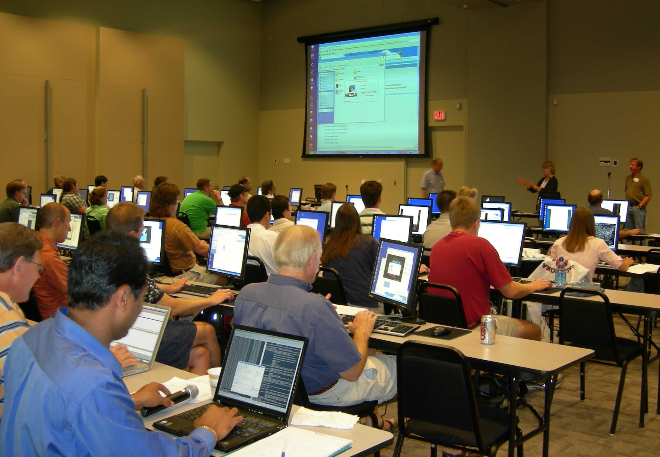

Figure X.2: Workshop participants have a hands-on experience with LEAD

Experiment Builder Orchestration

The portal allowed users to select from a list of four pre-composed workflows. Users first had the opportunity to select a workflow using either ADAS or NAM initialization and for each of these workflows they could pick either CONUS Domain, or a regional 600kmX600km domain with either the horizontal grid spacing of 5km or 20km, users were given an option to perform either a six- or twelve-hour forecast over the selected region.

A total of 73 workflows were launched by the two groups of participants. Four of the workflows failed to finish because the system did not use a comprehensive user input validation, and the four users have selected a wrong combination of ADAS Initialized data and Boundary Conditions. There were few problems because of middle ware issues. The gridftp server on the Unidata LEAD test bed machine where the input data was hosted and the output results were cataloged in THREDDS server encountered problems when 10 gridftp concurrent transfers were attempted to the machine. Apart from this the Generic Factory Service crashed twice and one of the Resource Catalog crawls returned no results, the reasons are still unknown at the time of writing this report and still being investigated. These problems gave a very good opportunity to resurrect user launched workflows by the GPEL workflow system administrator. The resurrection capability of the workflow system helped to identify the potential failures at run-time and the second attempt workflow execution finished successfully. On the whole except the four workflows launched by users with incorrect inputs, rest of all the workflows produced meaningful results and cataloged them in users personal space accessible from the portal interface.

Siege Client Orchestration

While Siege is a general purpose framework for creating workflows, workshop participants were presented with a tailored application for launching WRFSI initialized WRF forecasts. In order to give users the complete experience, users downloaded and installed the client software. Next, users could configure a default forecast length and also the number of processors to use. These values can also be overridden on a per-experiment basis.

The first session achieved eighteen submissions of which fifteen were left pending while three became active. This first attempt at a large-scale test showed that Siege services were paralyzed by the volume of events, which provoked a failure in the message bus (ActiveMQ). When messages stopped flowing, subsequent operations were hung as well; this meant that nothing could go forward.

Siege developers determined this problem on the fly and applied a quick patch to the execution service that would mitigate this particular bottleneck by reducing the number of file events. Unfortunately, this required a reboot of all the services. The loss of events meant that even the three active jobs which completed would not be visible to the users who submitted them.

The second session had seventeen submissions (eleven successes and six failures). One failure was due to a user submitting a 24-hour forecast so the job exceeded the time allotment. The rest of the failures were due to missing files, likely due to gridftp problems described next.

A significant overall point of failure for both systems was the 100Base-T network card of the gridftp server on the Unidata test bed, which simply could not serve such a large and concentrated volume of data requests. [Comment from Jay: I think this warrants further analysis. Sure, a GIGE card would be far better for sustained bandwidth, but, even that can have its limits (backplane of system bandwidth, number of concurrent connections demanding bandwidth, etc). What I would expect/prefer would be tolerance of a lot of connections, all performing transactions, setting up transfers, etc – but a consistent (and perhaps consistently degraded) level of performance, based on the number of connections against the potential bandwidth. What we saw was weird failure conditions and messages that I believe indicated that the gridftp server could not handle the request, but told us something like “not in gridmapfile” (when in fact, they were). I think it would be worth further study to see what is going on, and then to suggest ways to remedy it (beyond adding bandwidth). We’ve seen the same behavior to mass store, but worse – in which no error is thrown, but the connections hang (and timeout on the server side, apparently) after about 3-4 concurrent connections are established.]

LEAD Education

While workshop participants waited for their Workflow/WRF experiments, LEAD education initiatives were presented. Participants were introduced to the Phenomenon Extraction Algorithm (PEA) developed by UAH for the purpose of mining data. The PEA objectively thins data based on user input variables to identify regions of interest, which are distributed to testbeds and used to generate a three-member WRF ensemble stored on a THREDDS server at Unidata. They learned of the glossary that has been developed for LEAD and the plans to expand this glossary into a LEAD ontology for educators and researchers. Web-based and portal accessible educational materials known as LEAD-to-Learn modules were presented. These modules, built by undergraduates at Millersville for use as supplements in undergraduate courses in atmospheric science, are interactive learning tools that contain content, context, examples, and visualizations using Unidata’s IDV. Finally, the project year 4 plans were previewed. Participants were encouraged to join the LEAD learning community and engage the LEAD team via shared workspaces that will soon be accessible through the LEAD portal.

General Outcomes

The amount of material to be presented was greater than the time allotment provided. Users would have been better served if they could have had more time to assimilate the information and processes presented. To a large extent this problem was unavoidable as the schedule had to be finalized months before it was clear what exactly we would be able to demonstrate at the workshop.

Users were given evaluation forms at the start of the lab. Many users responded to the evaluation questions as they used each system. The evaluation questions provided to the users are listed in Figure X. To date, these forms have been reviewed only partially, but will be analyzed further later.

Users’ Experiences

The overall impression from the users was that the capabilities provided by these orchestration systems were interesting and useful even though the technologies were still experimental and buggy. Users seemed to appreciate the value of being able to launch a WRF forecast without having to deal with the vast array of technical issues involved.

Perhaps not surprisingly, the user interface is a highly important component of both orchestration systems. In the evaluations, nearly all users had comments about the interface. Some found it easy, some did not, and others had opinions in between. All indicated that more and better documentation was needed. The Michigan Community Engagement team was present at the workshop to observe the use of the orchestration systems and identify further usability improvements. The team identified ways that the functionality and navigation could be clarified and improved in the future, including documentation, based on the participants’ difficulties and questions. The team also recorded explicit suggestions for ways of making the software consistent with existing conventions and expectations of meteorologists and students (e.g., preferred date and time notation systems). Some users preferred the web-based approach and indicated that they thought that people and students in particular would be more comfortable with that. Others cited network difficulties as a benefit of the local client approach taken by Siege.

Due to the fact that many of the capabilities became available shortly before the workshop, a lot of functionality was presented in a relatively short amount of time. This came through in many of the comments from the users. Many indicated an inability to evaluate the software because they didn’t have enough time to experience it and form an opinion. Many expressed an interest in a longer exposure to the capabilities.

Technical Lessons Learned

The value of restart capabilities was evident in the ability of the portal-launched jobs to be restarted in the face of problems. Also, the ability to retry capabilities, such as reissuing previously failed gridftp requests, demonstrated its value.

The Siege development team will be investigating different message bus implementations with the goal of finding one that can handle greater volumes.

Unidata will be looking to improve the network interface of its test bed in order to support greater volumes of gridftp requests.

We will also be looking in some detail to the performance of gridftp servers to increasing load; we may need to submit bugs to the gridftp development team at Argonne National Laboratory.

A number of very useful comments were received from the participants which will go into evolving that software. The following is a list of key comments for each orchestration system:

Siege:
- Non-Intuitive
- Installation could be better (e.g. use InstallShield)
- Really liked integration of IDV for domain selection
- Too many windows
- Liked that it was local client/Disliked that it was local client (!)
- Would prefer a more guided flow

Portal:
- Product lists are confusing and poorly put together (geo-gui search results) – repeated information makes for confusing interface
- Date/time for search interface is bothersome
- Can’t work with retrospective NAM data
- Too many boxes need to be checked for NAM/ADAS selections – confusing and could lead to mistakes – display structure needs reworking including dealing with repeated information
- Liked that it was web based/Disliked that it was web based (!)
- Non-Intuitive
- Somewhat slow response – “loading” indicators desirable – especially domain selection in geo-gui

Overall, the goals of the workshop were met. Users were introduced to the idea remotely launching forecasts and responded in a generally positive manner. Also, developers got plenty of valuable feedback regarding the user experience and stress test results.

Participants Interested in Beta Test

Workshop participants were asked if they would have interest in being Beta Testers for LEAD going forward. The following individuals expressed interest:

Guilherme O. Chagas goc@ufrj.br
Sen Chiao schiao@fit.edu
Gerry Creager gerry.creager@tamu.edu
Elen Cutrim cutrim@wmich.edu
Bill Gallus wgallus@iastate.edu
Brendon Hoch bhoch@plymouth.edu
Rudolf Husar rhusar@me.wustl.edu
Eric Kelsey ekaborsa@hotmail.com
Jana Lesak Jana.B.Lesak_1@ou.edu
Ricardo Nogueira rnogue1@lsu.edu
Jon Petters jpetters@meteo.psu.edu
Alan Srock srock@atmos.albany.edu
Donna Tucker dtucker@ku.edu
Mark Wysocki mww3@cornell.edu

